Student Groups

Objective
To explain how to activate or inactivate a student group code on a student’s record manually or by using a mass process.
PeopleSoft Category: Campus Community
Table of Contents

Lesson 1: activate a student group 2
Lesson 2: inactivate a student group 3
Lesson 3: MAss ACtivate/inactivate student groups using query 4
Lesson 4: Mass activate/inactivate student groups using an External file 9
If you have additional questions about the instructions and information in this process guide, please go to the Enterprise Applications section of the IT Department Staff page on the Sonoma State website to find a staff resource.
For other guides, visit How Tos and FAQs under the Enterprise Applications heading.
If you encounter an accessibility problem with this document, please report an accessibility problem on the Sonoma State website.
Please note: to access the hyperlinks in this document, hold down CTRL on your keyboard while you click the link.

Lesson 1: Activate a Student Group
Introduction: Student Groups allow for the tracking of students based on a group or classification they belong to (i.e. DSS, Honors, Student Ambassadors, International Student, etc.). A student stays in a Student Group until they are made inactive from that group (see Lesson 2: Inactivating a Student Group). All Student Groups must be maintained by the office assigning the group to the student’s record.
Navigation: Main Menu > Records and Enrollment > Career and Program Information > Student Groups
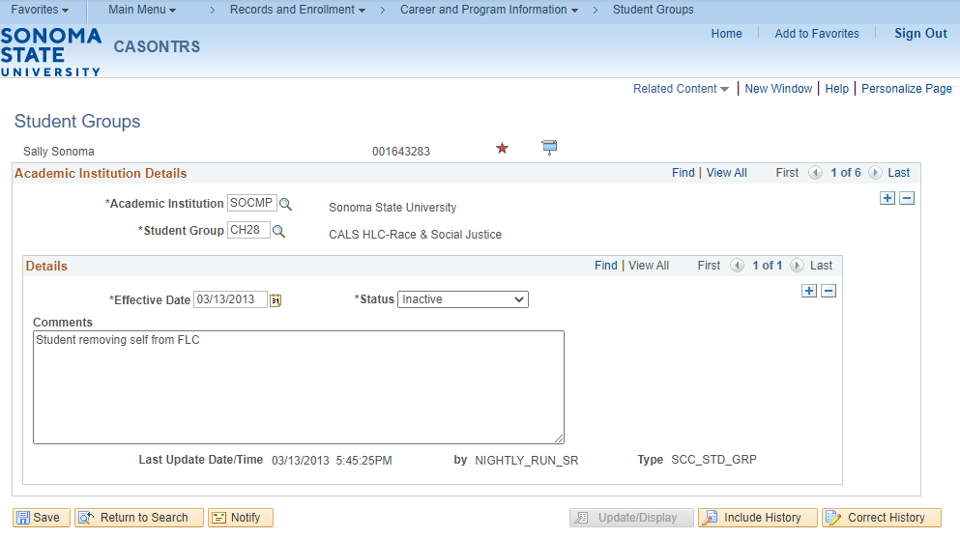
On the Student Groups page click on the plus button in the upper right corner under Academic Institution Details to add a student group to a student.
- The Academic Institution should default to SOCMP
- Enter the code for the student group. If you do not know the code, click on the magnifying glass to search for the code.
- The Effective Date will populate with today’s date, you can update this if needed.
- The Status will default to Active.
- The Comments box is optional.
- Once all information is filled in on this page click the Save button.

Lesson 2: Inactivate a Student Group
Introduction: Student Groups allow for the tracking of students based on a group or classification they belong to (i.e. DSS, Honors, Student Ambassadors, International Student, etc.). A student stays active (see Lesson 1: Activating a Student Group) in a Student Group until they are made inactive from that group. All Student Groups must be maintained by the office assigning the group to the student’s record.
Note: Student group activation and inactivation dates should not be set to the same date. Always make sure the inactivation date is at least one date after the activation.
Navigation: Main Menu > Records and Enrollment > Career and Program Information > Student Groups
On the Student Groups page, if there is more than one student group attached to the student’s record, make sure you are on the correct one. Under the Details section click on the plus button to add a row. NOTE: In most cases it is important that history be preserved. Always add a row when inactivating a student group.
- The Effective Date will populate with today’s date, you can update this if needed.
- The Status will default to Inactive.
- The Comments box is optional.
- Once all information is filled in on this page click the Save button.
Lesson 3: Mass Activate/Inactivate Student Groups using Query
Introduction: The process for activating or inactivating a group of students to a student group can be run with or without using the Population Selection method. Population Selection allows you to use a query to identify students for activating or inactivating students in a student group. If you use the Population Selection PS Query option, you must include the STDNT_GRP_BIND record in the query to place it in the list of eligible queries on the Process Student Group page. Please contact your Enterprise Applications lead in order to make sure that the query you are using has this bind record.
Note: When inactivating a group of students, it should never be set for the same date as the activation row. For example, if you activate a group of students for the RATH student group on 5/21/20 the earliest they can/should be inactivated is 5/22/20. Never run an activation and inactivation on the same day. For questions or concerns please contact your Enterprise Applications functional lead.

Navigation: Main Menu > Records and Enrollment > Career and Program Information > Process Student Groups
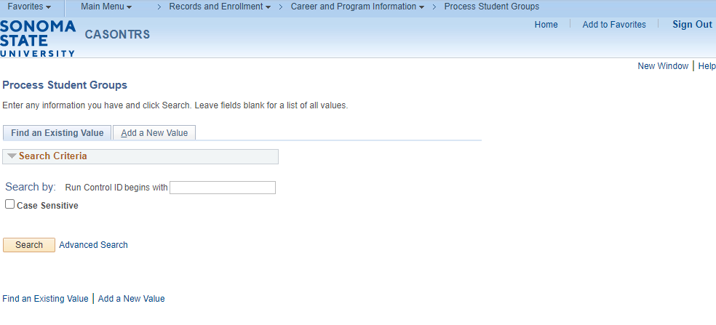
On the Process Student Groups Run Control page enter in the run control ID if a run control already exists and click the Search button. If a run control ID does not exist click on the Add a New Value tab and enter a name for the run control and click Add.
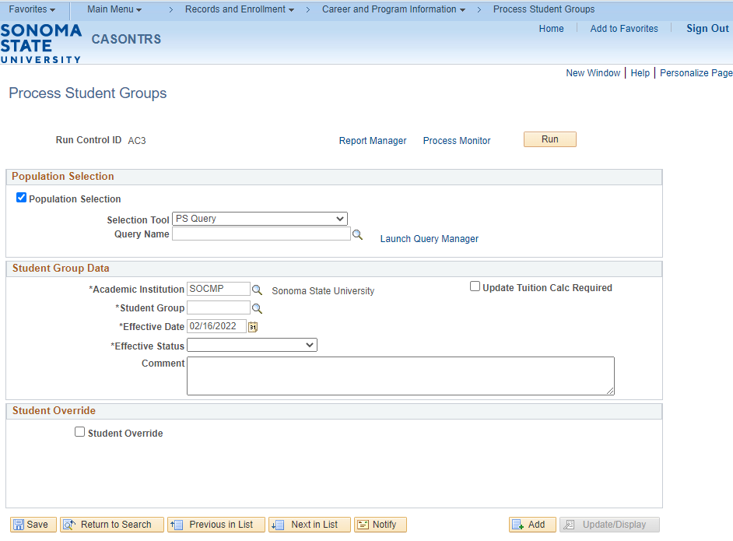
On the Process Student Groups page, you will want to do the following:
- For the Selection Tool select PS Query.
- For the Query Name select the query that you would like to use for this process. Please note that in order to use this option you need to include the STDNT_GRP_BIND record in your query, otherwise the query cannot be used in this process. If you don’t know the name of the query that you wish to use or don’t know if the STDNT_GRP_BIND record has been attached to the query, click the magnifying glass to see if the query shows up. If the query you need is not there, contact Enterprise Applications.
- Click on the Edit Prompts link to enter in any prompts that are needed to run the query. (This option will only show up if your query requires prompts).
- Click on the Preview Selection Results to see how many rows the query returns. Note: The preview will only show the first 300 rows.
- Under Student Group Data Institution should default to SOCMP.
- Enter the student group code that you wish to assign in the Student Group box.
- Enter an effective date to use for all of the IDs assigned to the student group. The default value is the current system date.
- Set the Effective Status to Active or Inactive. As a reminder, never activate and inactivate a student group on the same day.
- Optional: Enter a comment that you want to assign to each student for the process.
- Once everything has been entered on this page click the Save button.
- Click the Run button in the upper right, this will bring you to the Process Scheduler Request page.

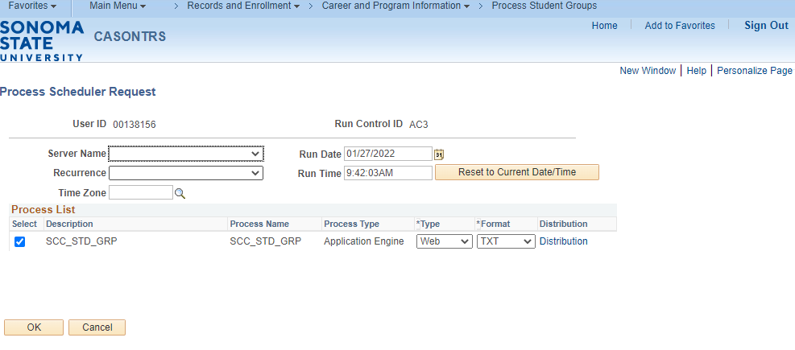
Once on the Process Scheduler Request page you will need to do the following:
- The Server Name should be blank or PSUNX.
- Click the OK button
- After clicking the OK button, you will be brought back to the Process Student Groups page.

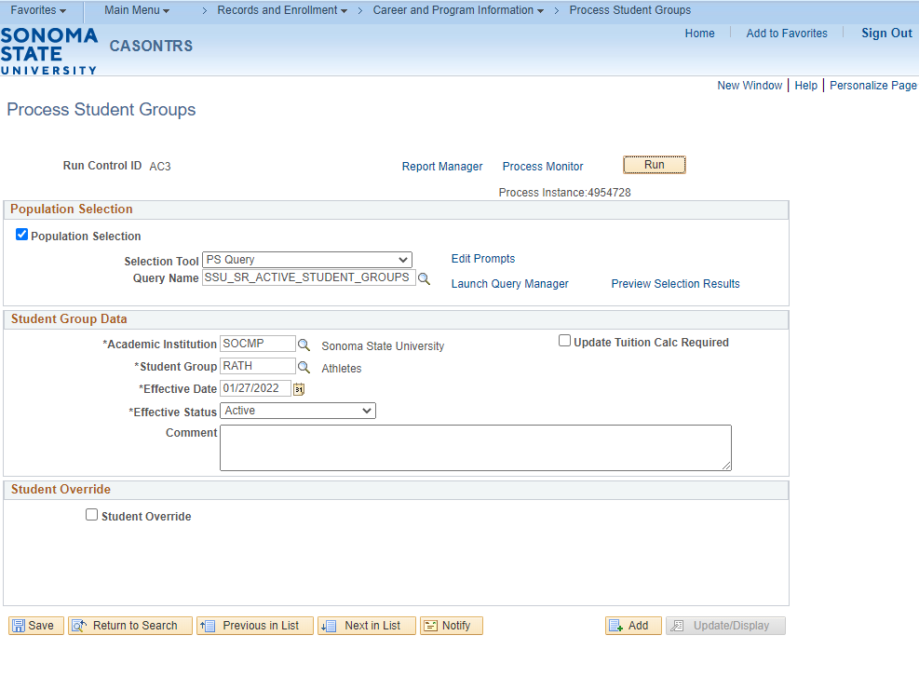
Once you are back on the Process Student Groups page you will want to click the Process Monitor link. This will open the Process Monitor page.

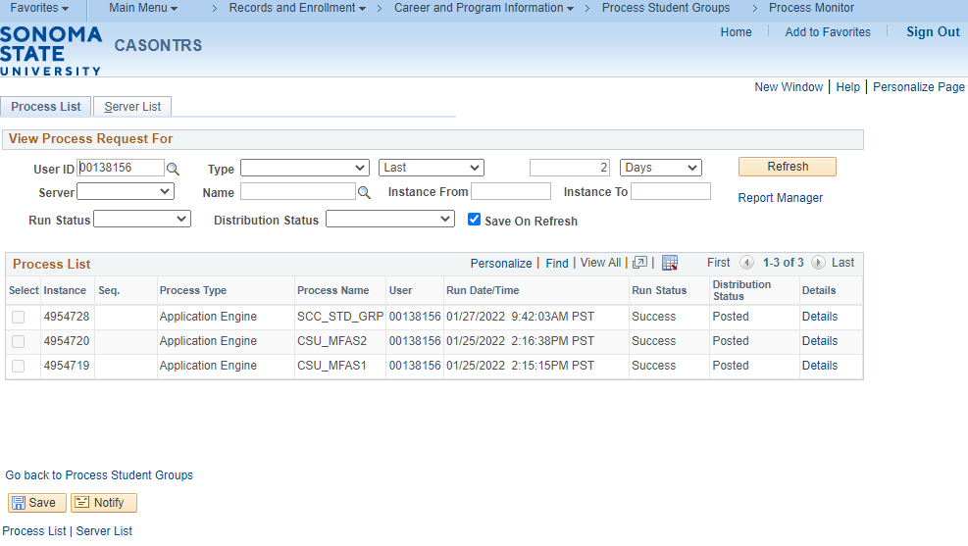
Once on this page you will need to click the Refresh button, until you get Success under Run Status and Posted under Distribution Status. The process is now complete.

Lesson 4: Mass Activate/Inactivate Student Groups Using an External File
Introduction: The process for activating or inactivating a group of students in a student group can be run using an external file. The steps below will walk you through the process of using an external file to load a student group to a list of students. The external file should be in .csv format and should have only emplids (Student IDs) in the file. Before you save the file as a .csv format make sure that the full emplid is listed including the zeros. Once the file is saved the .csv format will drop the leading zeros.

Navigation: Main Menu > Records and Enrollment > Career and Program Information > Process Student Groups
On the Process Student Groups Run Control page enter in the run control ID if a run control already exists and click the Search button. If a run control ID does not exist click on the Add a New Value tab and enter a name for the run control and click Add.

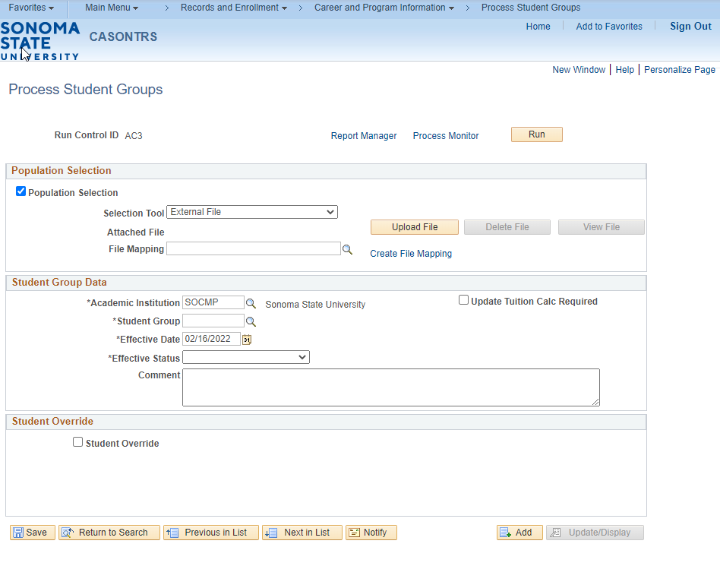

On the Process Student Groups page, you will want to do the following:
- For the Selection Tool select External File.
- Click the Upload File button.
- Click the magnifying glass next to File Mapping and select the Student Group Load file mapping.
- Click on the Preview Selection Results to make sure the file looks correct. Note: The preview will only show the first 300 rows.
- Under Student Group Data Institution should default to SOCMP.
- Enter the student group code that you wish to assign in the Student Group box.
- Enter an effective date to use for all of the IDs assigned to the student group. The default value is the current system date.
- Set the Effective Status to Active or Inactive. As a reminder, never activate and inactivate a student group on the same day.
- Optional: Enter a comment that you want to assign to each student for the process.
- Once everything has been entered on this page click the Save button.
- Click the Run button in the upper right, this will bring you to the Process Scheduler Request page.

Once on the Process Scheduler Request page you will need to do the following:
- The Server Name should be blank or PSUNX.
- Click the OK button
- After clicking the OK button, you will be brought back to the Process Student Groups page.

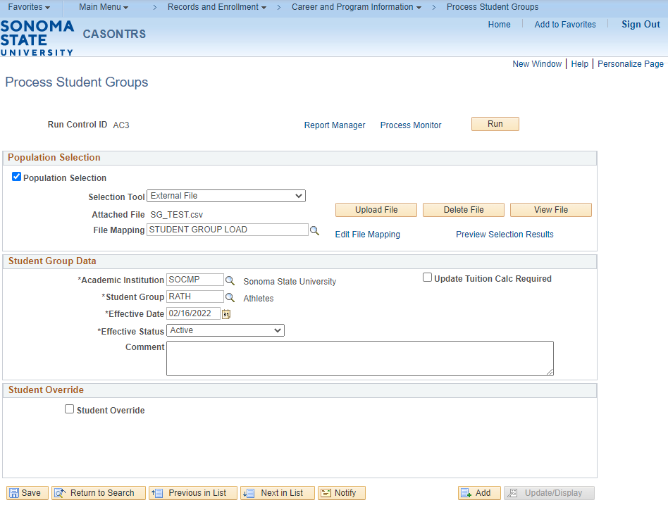

Once you are back on the Process Student Groups page you will want to click the Process Monitor link. This will open the Process Monitor page.

Once on this page you will need to click the Refresh button, until you get Success under Run Status and Posted under Distribution Status. The process is now complete.

