Service Indicators (Holds)

Objective
To explain how to place or lift a service indicator (hold) on a student’s record manually or by mass.
PeopleSoft Category: Campus Community
Table of Contents

Lesson 1: Placing a service indicator (hold) 2
Lesson 2: Lifting a service indicator (Hold) 5
Lesson 3: Mass assign using ps query 7
Lesson 4: Mass assign using an external file 13
LESSON 5: MASS RELEASE USING PS QUERY…………………………………………….19
LESSON 6: MASS RELEASE USING AN EXTERNAL FILE………………………………..24
If you have additional questions about the instructions and information in this process guide, please go to the Enterprise Applications section of the IT Department Staff page on the Sonoma State website to find a staff resource.
For other guides, visit How Tos and FAQs under the Enterprise Applications heading.
If you encounter an accessibility problem with this document, please report an accessibility problem on the Sonoma State website.
Please note: to access the hyperlinks in this document, hold down CTRL on your keyboard while you click the link.

Lesson 1: Placing a Service Indicator (Hold)
Introduction: Service Indicators (Holds) can be placed for students who are not yet in compliance with university regulations (i.e., department advising disqualifications, etc.). This lesson will take you through the steps needed to put a hold on an individual student.
Navigation: Main Menu > Campus Community > Service Indicators (Student) > Manage Service Indicators
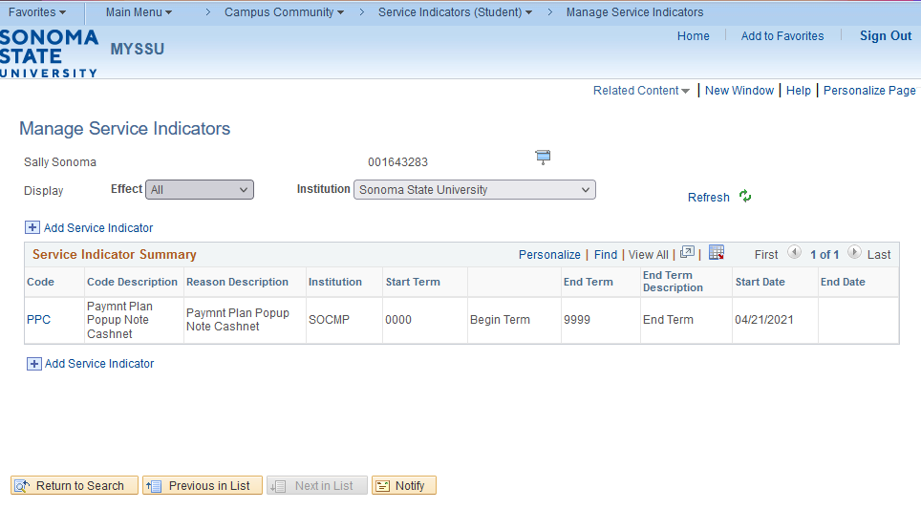
On the Manage Service Indicators page click on the blue Add Service Indicator link to add a new service indicator.
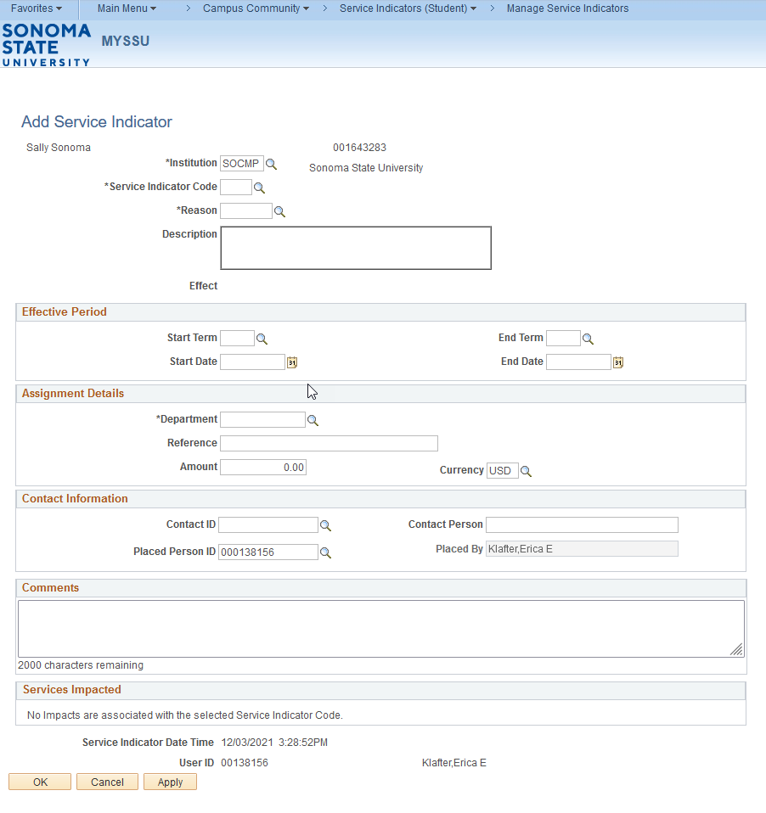

On the Add Service Indicator page:
- SOCMP should be listed for Instituction.
- Enter the Service Indicator Code.
- Enter in the Reason.
- Under the Effective Period section, you can enter in the Start Term and/or Start Date. Most service indicators are setup with a start term of 0000.
- Under the Contact Information section the Placed Person ID will populate. If this needs to be change you can update now. Be aware that the students WILL see this person’s name and email address through student self-service.
- The Comments section is for internal purposes only. Be aware that a student WILL NOT be able to see the information contained in this file.
Once everything is filled out correctly click the yellow OK button to get back to the Manage Service Indicators page.

Lesson 2: Lifting a Service Indicator (Hold)
Introduction: Service Indicators (Holds) can be lifted when students are one again in compliance with university regulation (i.e., department advising, disqualifications, etc.). This lesson will take you through the steps needed to lift a hold on an individual student. It is necessary to retain a history of service indicators as we have a Service Indicator audit that contains this information.
Navigation: Main Menu > Campus Community > Service Indicators (Student) > Manage Service Indicators
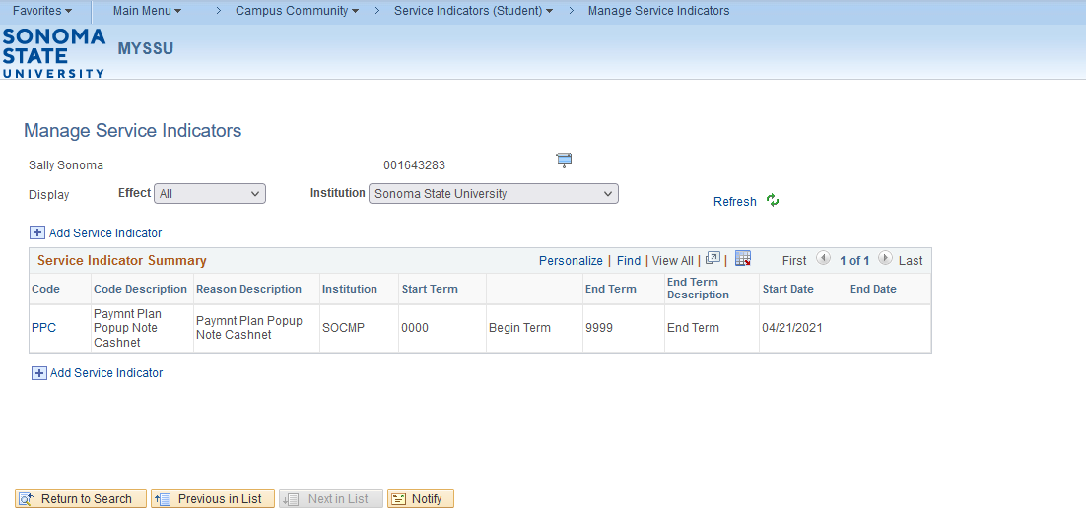
The above screenshot will list any service indicators (holds) that have been assigned to a student. In order to lift a hold, click on the blue code link on the left hand side of the screen that you wish to lift.
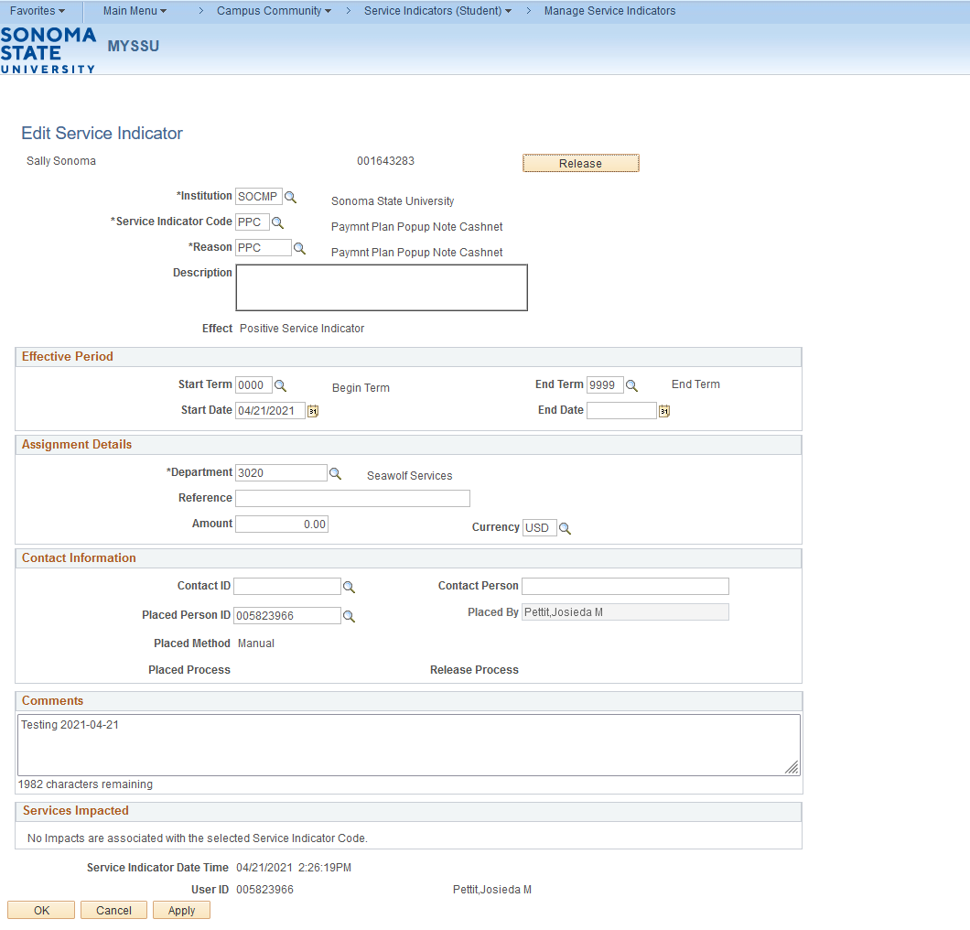
In the above screenshot you will see a yellow release button located on the Edit Service Indicator page. In order to lift the hold, you will need to click on the release button. After clicking on this button, a message will display asking if you are sure you want to release this Service Indicator. If you are sure you want to release the service indicator click on the OK button. If not click on the Cancel button.

Lesson 3: Mass Assign Using PS Query
Introduction: This lesson will describe the process of mass assigning a service indicator to a list of students using PS Query. If you use the PS Query option, you must include the SCC_BND_SRCIND record in the query to place it in the list of eligible queries on the Mass Assign page. Please contact your CMS lead in order to make sure that the query you are using has this bind record.
Please note that if a student in your query already has the service indicator that you are trying to assign, the process will add a duplicate service indicator onto the student’s record.

Navigation: Main Menu > Campus Community > Service Indicators (Student) > Mass Assign
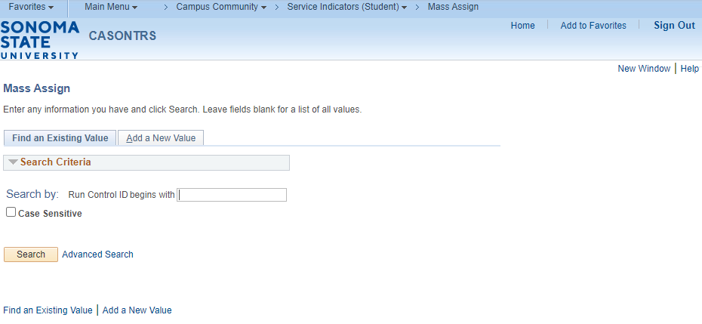

On the Mass Assign Run Control page enter in the run control ID if a run control already exists and click the Search button. If a run control ID does not exist click on the Add a New Value tab and enter a name for the run control and click Add.
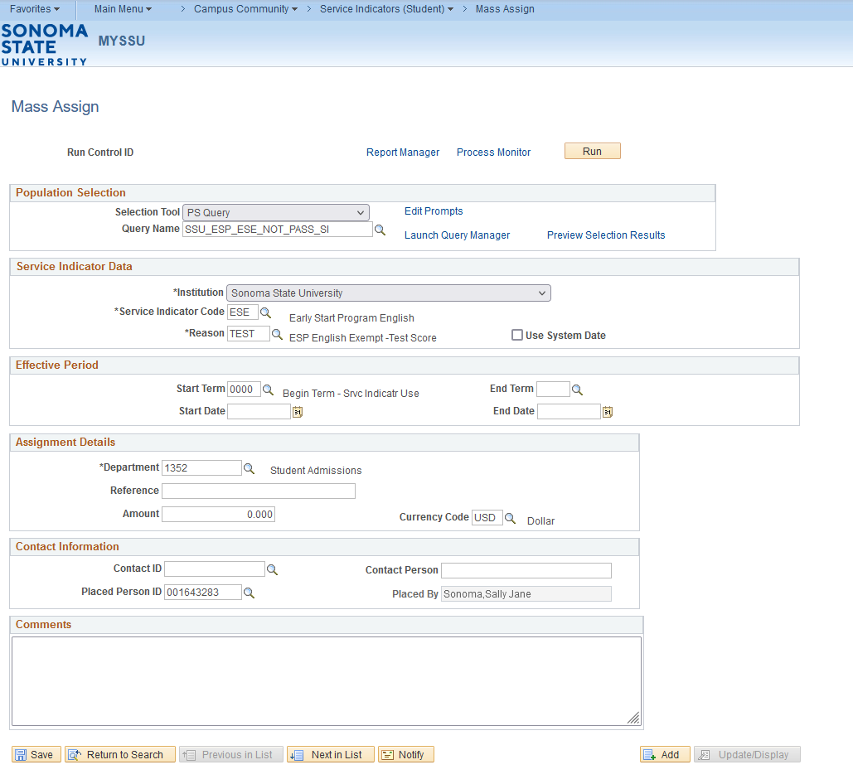

On the Mass Assign page you will want to do the following:
- For the Selection Tool select PS Query.
- For the Query Name select the query that you would like to use for this process. Please note that in order to use this option you need to include the SCC_BND_SRCIND record in your query, otherwise the query cannot be used in this process. If you don’t know the name of the query that you wish to use or don’t know if the SCC_BND_SRCIND record has been attached to the query, click the magnifying glass to to see if the query shows up.
- Click on the Edit Prompts link to enter in any prompts that are needed to run the query. (This option will only show up if your query requires prompts).
- Click on the Preview Selection Results to see how many rows the query returns.
- Under Service Indicator Data Institution should default to Sonoma State University.
- Enter the service indicator code that you wish to assign in the Service Indicator Code box.
- Enter the reason that you wish to assign in the Reason box.
- Under Effective Period you can enter a start term or leave the start term as 0000 and the service indicator will stay on until it is released.
- Enter the start date in the Start Date box.
- Under Assignment Details the department will default to the department that is tied to the service indicator that is being assigned.
- Under Contact Information the Placed Person ID and Placed By name will default to the person that is assigning the Service Indicator. If you are assigning this for someone else you will want to charge the Placed Person ID.
- Enter a comment that you want to assign to each student for the process (This is an optional step).
- Click the Save button to save the items you entered on this page.
- Click the Run button to run the process.

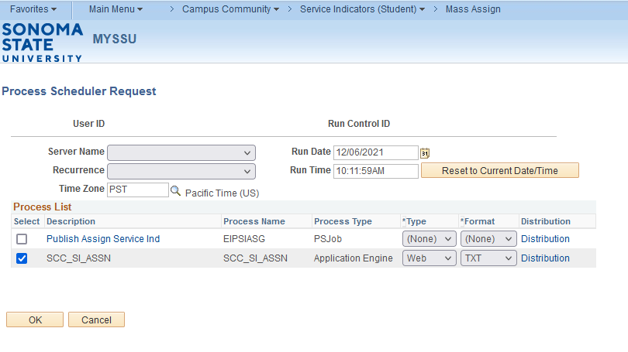
Once on the Process Scheduler Request page you will need to do the following:
- The Server Name should be blank or PSUNX.
- Under Process List check the box for SCC_SI_ASSN.
- Click the OK button
- After clicking the OK button, you will be brought back to the Mass Assign page.

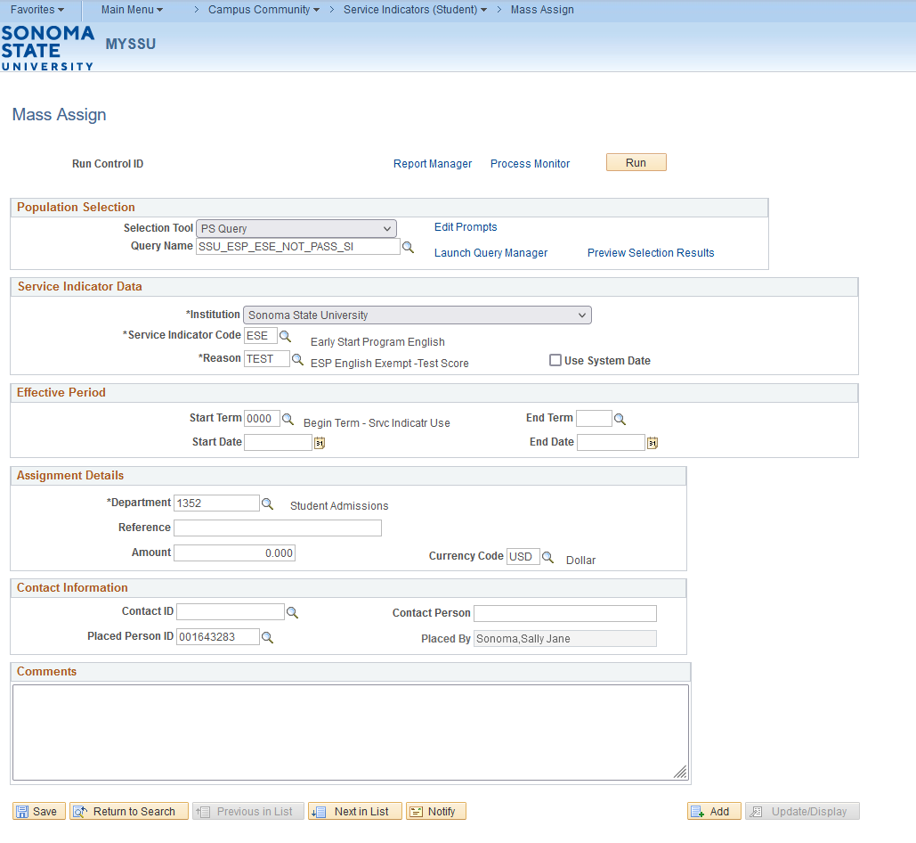
Once you are back on the Mass Assign page you will want to click the Process Monitor link. This will open the Process Monitor page.

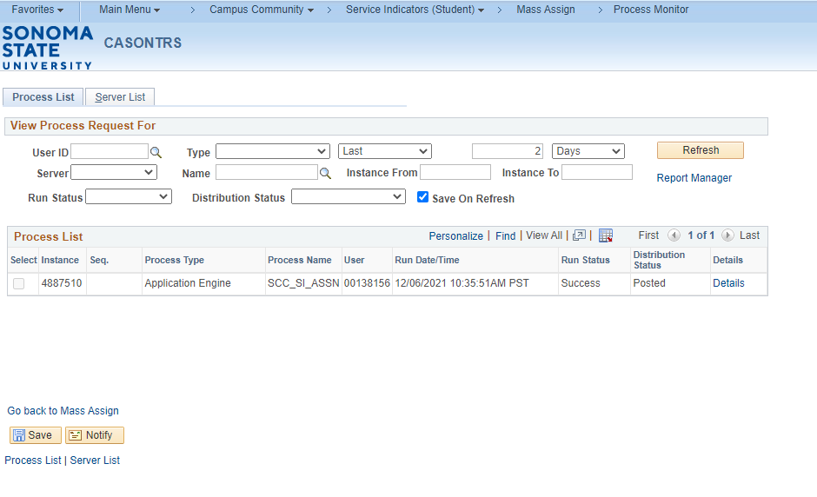
Once on this page you will need to click the Refresh button, until you get Success under Run Status and Posted under Distribution Status. The process is now complete.

Lesson 4: Mass Assign Using an External File
Introduction: The process for assigning a group of students a service indicator can be run using an external file. The steps below will walk you through the process of using an external file to load service indicators to a list of students. The external file should be in .csv format and should have only emplids in the file.

Please note that if a student in your file already has the service indicator that you are trying to assign, the process will add a duplicate service indicator onto the student’s record.

Navigation: Main Menu > Campus Community > Service Indicators (Student) > Mass Assign

On the Mass Assign Run Control page enter in the run control ID if a run control already exists and click the Search button. If a run control ID does not exist click on the Add a New Value tab and enter a name for the run control and click Add.

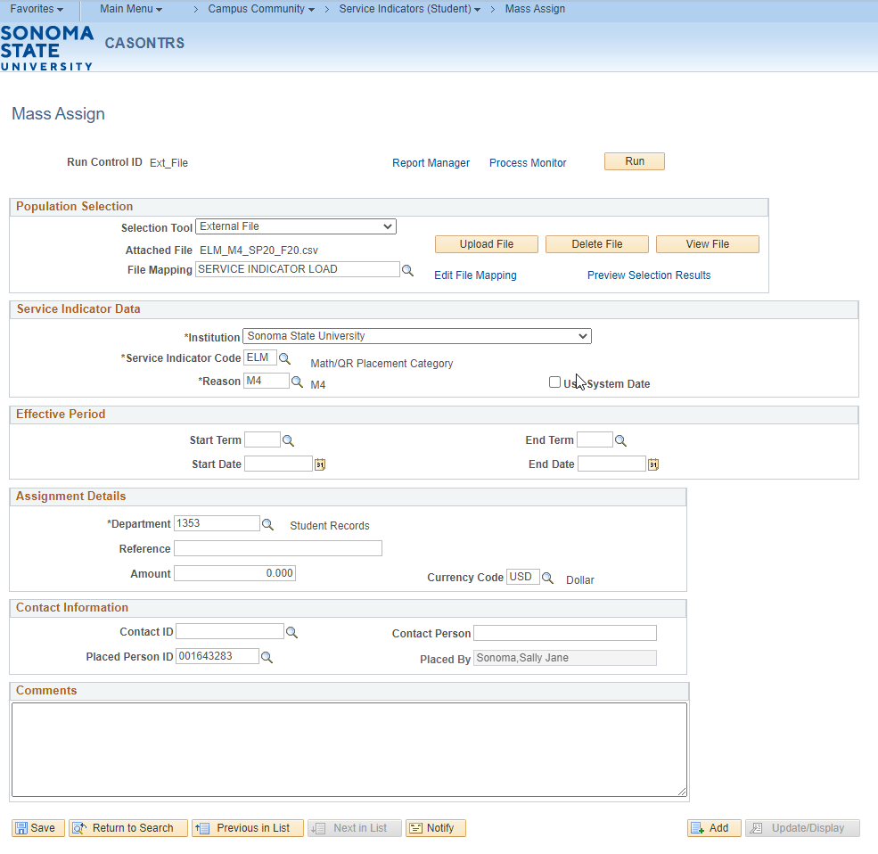

On the Mass Assign page you will want to do the following:
- For the Selection Tool select External File.
- Click the Upload File button to upload the file.
- Once the file has been uploaded, the file name will appear next to the Attached File.
- For the File Mapping select Service Indicator Load.
- Click on the Preview Selection Results link to view your file that has been uploaded.
- Under Service Indicator Data Institution should default to Sonoma State University.
- Enter the service indicator code that you wish to assign in the Service Indicator Code box.
- Enter the reason that you wish to assign in the Reason box.
- Under Effective Period you can enter a start term or leave the start term as 0000 and the service indicator will stay on until it is released.
- Enter the start date in the Start Date box.
- Under Assignment Details the department will default to the department that is tied to the service indicator that is being assigned.
- Under Contact Information the Placed Person ID and Placed By name will default to the person that is assigning the Service Indicator. If you are assigning this for someone else you will want to charge the Placed Person ID.
- Enter a comment that you want to assign to each student for the process (This is an optional step).
- Click the Save button to save the items you entered on this page.
- Click the Run button to run the process.

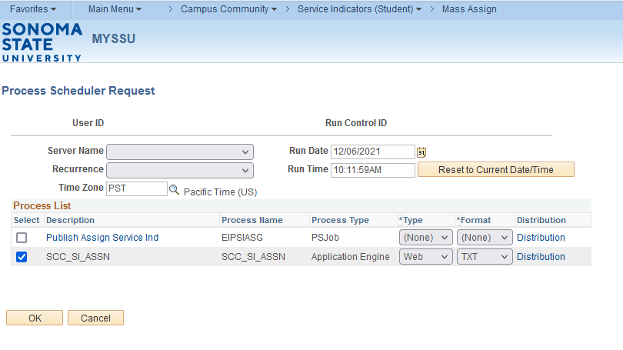
Once on the Process Scheduler Request page you will need to do the following:
- The Server Name should be blank or PSUNX.
- Under Process List check the box for SCC_SI_ASSN.
- Click the OK button
- After clicking the OK button, you will be brought back to the Mass Assign page.

Once you are back on the Mass Assign page you will want to click the Process Monitor link. This will open the Process Monitor page.

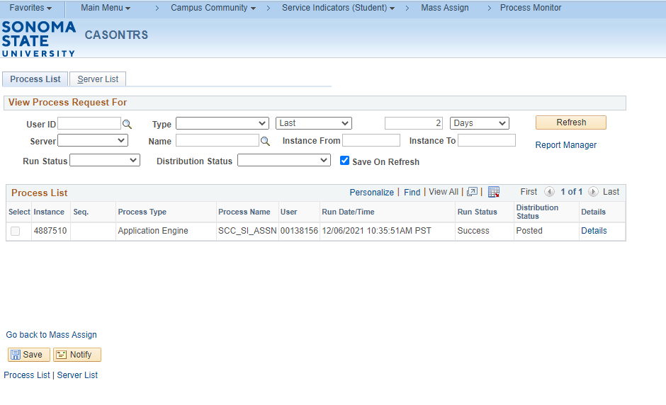
Once on this page you will need to click the Refresh button, until you get Success under Run Status and Posted under Distribution Status. The process is now complete.

Lesson 5: Mass Release Using PS Query
Introduction: This lesson will describe the process of mass releasing a service indicator to a list of students using PS Query. If you use the PS Query option, you must include the SCC_BND_SRCIND record in the query to place it in the list of eligible queries on the Mass Release page. Please contact your CMS lead in order to make sure that the query you are using has this bind record.

Navigation: Main Menu > Campus Community > Service Indicators (Student) > Mass Release
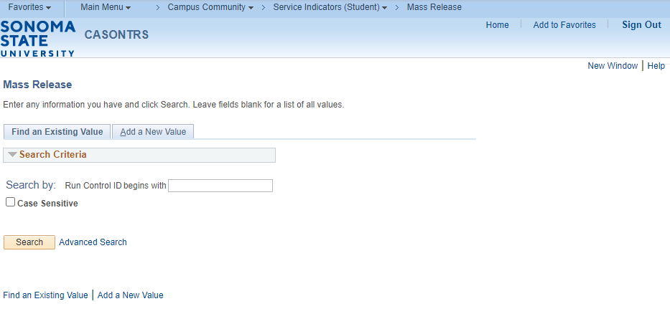

On the Mass Release Run Control page enter in the run control ID if a run control already exists and click the Search button. If a run control ID does not exist click on the Add a New Value tab and enter a name for the run control and click Add.

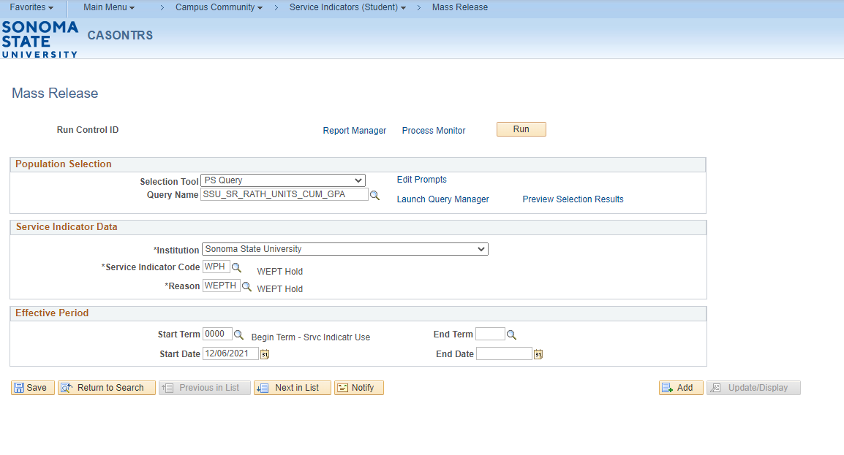
On the Mass Release page, you will want to do the following:
- Select PS Query for the selection tool.
- Under Query Name enter the name of the query that you would like to use for this process. Please note that in order to use this option you need to include the SCC_BND_SRCIND record in your query, otherwise the query cannot be used in this process. If you don’t know the name of the query that you wish to use or don’t know if the SCC_BND_SRCIND record has been attached to the query, click the magnifying glass to see if the query shows up.
- Click on the Edit Prompts link to enter in any prompts that are needed to run the query. (This option will only show up if your query requires prompts).
- Click on the Preview Selection Results to see how many rows the query returns.
- Under Service Indicator Data Institution should default to Sonoma State University.
- Enter in the Service Indicator Code that you wish to release.
- Enter in the Reason that you wish to release.
- Under Effective Period if the query that is being used has a combination of start dates all the service indicators will be released if the Start Date is left blank or you can control the population that gets released by entering in a Start Date.
- Click on the Save button to save this page.
- Click on the Run button to run the process.

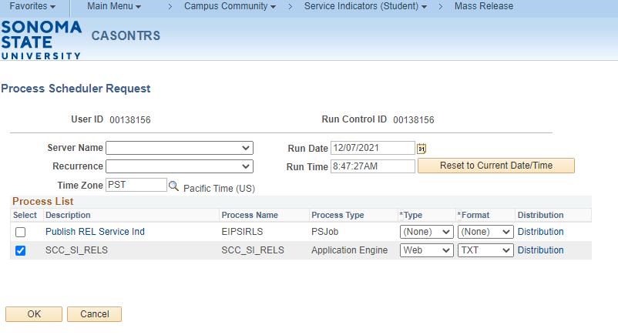
On the Process Scheduler Request page, you will want to do the following:
- The Server Name should be blank or set to PSUNX
- Under Process List click on the checkbox next to SCC_SI_RELS.
- Click on the OK button to return to the Mass Release screen.

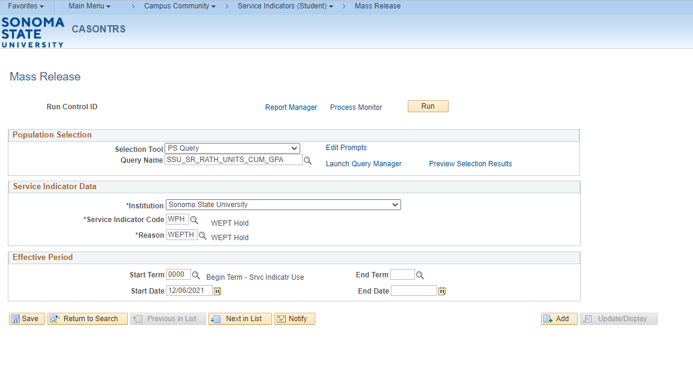
On the Mass Release page click on the Process Monitor Link, this will take you to the Process Monitor page.

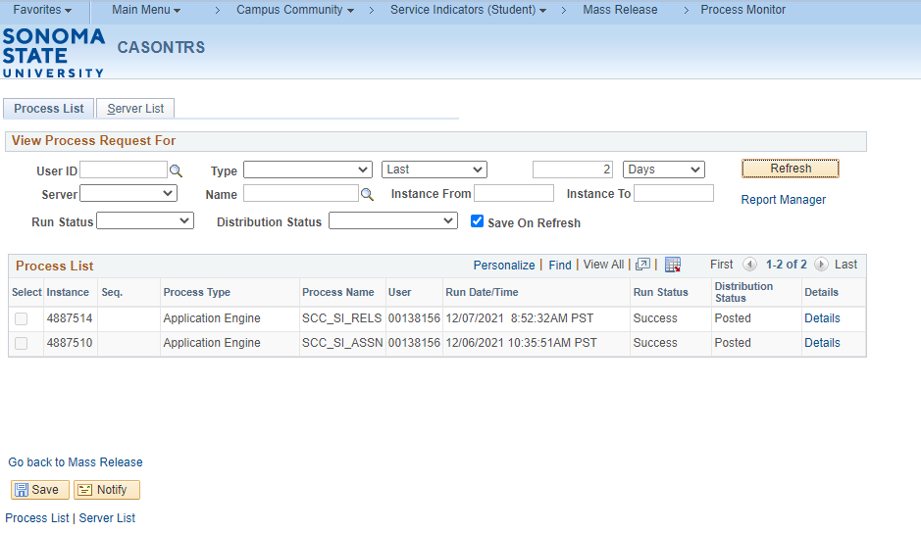

On the Process Monitor page click on the Refresh button until the Run Status is Success and the Distribution Status is Posted. This process is now complete.

Lesson 5: Mass Release Using an External File
Introduction: The process for releasing service indicators can be run using an external file. The steps below will walk you through the process of using an external file to release service indicators to a list of students. The external file should be in .csv format and should have only emplids in the file.

Navigation: Main Menu > Campus Community > Service Indicators (Student) > Mass Release

On the Mass Release Run Control page enter in the run control ID if a run control already exists and click the Search button. If a run control ID does not exist click on the Add a New Value tab and enter a name for the run control and click Add.

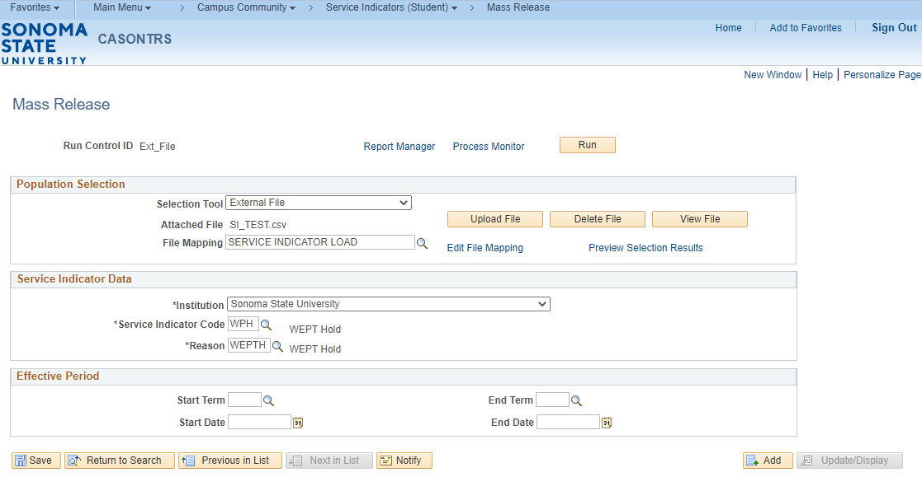
On the Mass Release page, you will want to do the following:
- Select External file for the selection tool.
- Click the Upload File button.
- Once the file has been uploaded, the file name will appear next to Attached File.
- Select the File Mapping name Service Indicator Load.
- Click on the Preview Selection Results link to view your file that has been uploaded.
- Under Service Indicator Data Institution should default to Sonoma State University.
- Enter in the Service Indicator Code that you wish to release.
- Enter in the Reason that you wish to release.
- Under Effective Period if the file that is being used has a combination of start dates all the service indicators will be released if the Start Date is left blank or you can control the population that gets released by entering in a Start Date.
- Click on the Save button to save this page.
- Click on the Run button to run the process.

On the Process Scheduler Request page, you will want to do the following:
- The Server Name should be blank or set to PSUNX
- Under Process List click on the checkbox next to SCC_SI_RELS
- Click on the OK button to return to the Mass Release screen.

On the Mass Release page click on the Process Monitor Link, this will take you to the Process Monitor page.

On the Process Monitor page click on the Refresh button until the Run Status is Success and the Distribution Status is Posted. This process is now complete.

