How To Avoid OnBase Locks

Problem: An OnBase form appears locked (read-only) eliminating the ability to make updates.

Causes:
- Someone Else Has The File Open: When a file is open, it becomes locked and read-only to anyone who also tries to open it. Once the form is closed, another user may open it and make change.
- A Session Was Disconnected: An issue can be experienced when a form is open and the internet connection is disconnected. This will make the form read only to all, including the user who did not close the form. A connection can be disconnected if the form is open and your computer goes into hibernation, sleep, or is shut down. To resolve this for Faculty, contact Vanessa. For all other users, contact the IT Helpdesk or Ryan.
- Google Chrome Users: Chrome has a new setting that maintains the user’s session even after the form is closed.

Solutions:
- Properly close the form when updates are done or work is complete. Do not leave the form open overnight, or let your computer sleep/hibernate/shut down when the form is open.
- Use a browser other than Chrome. Copy and paste the link (without clicking on it) from the notification email.
- If using Chrome, change the settings to forget previous instances (see below).

Steps to change the Chrome Settings:

- Close all instances of Chrome and then open a new tab
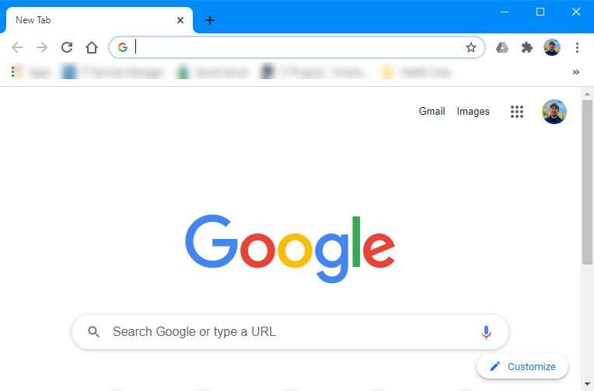

- Type in the address bar chrome://flags.
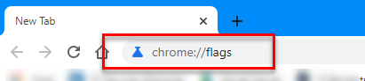
- View the page that pops up in the Chrome window.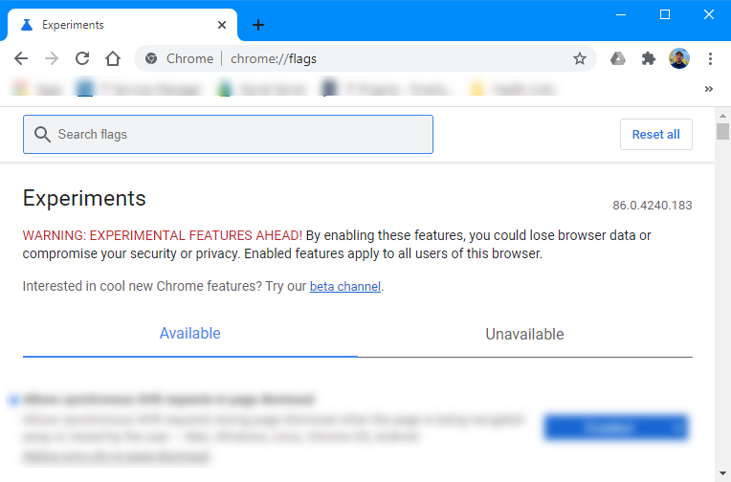

- In the search box, enter Page Dismissal.
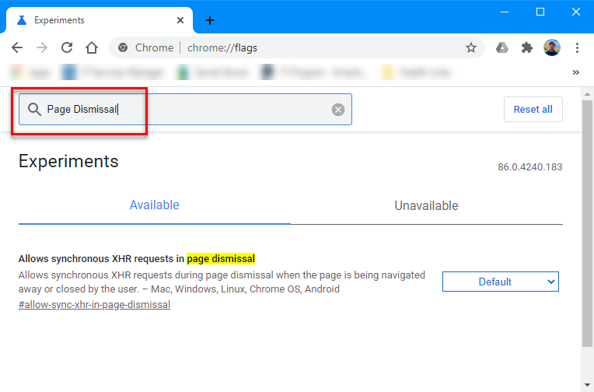
- Set the Allow Synchronous XHR requests in page dismissal to Enabled.
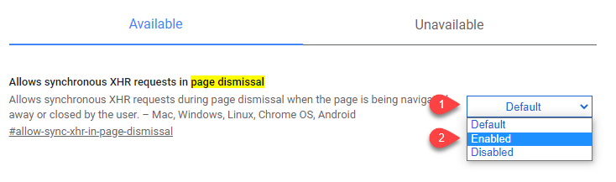

- Click the Relaunch button
