Faculty Access to the PeopleSoft Class Search

Objective
To explain how to access and search for classes in PeopleSoft using Class Search.
PeopleSoft Category: Student Records
Table of Contents

Lesson 1: Using the class search 2

If you have additional questions about the instructions and information in this process guide, please go to the Enterprise Applications section of the IT Department Staff page on the Sonoma State website to find a staff resource.
For other guides, visit How Tos and FAQs under the Enterprise Applications heading.
If you encounter an accessibility problem with this document, please report an accessibility problem on the Sonoma State website.
Please note: to access the hyperlinks in this document, hold down CTRL on your keyboard while you click the link.

Lesson 1: Using the Class Search
Introduction: This lesson will show you how to use the class search feature in PeopleSoft.
Navigation: Main Menu > Self Service > Faculty Center > My Schedule > Class Search
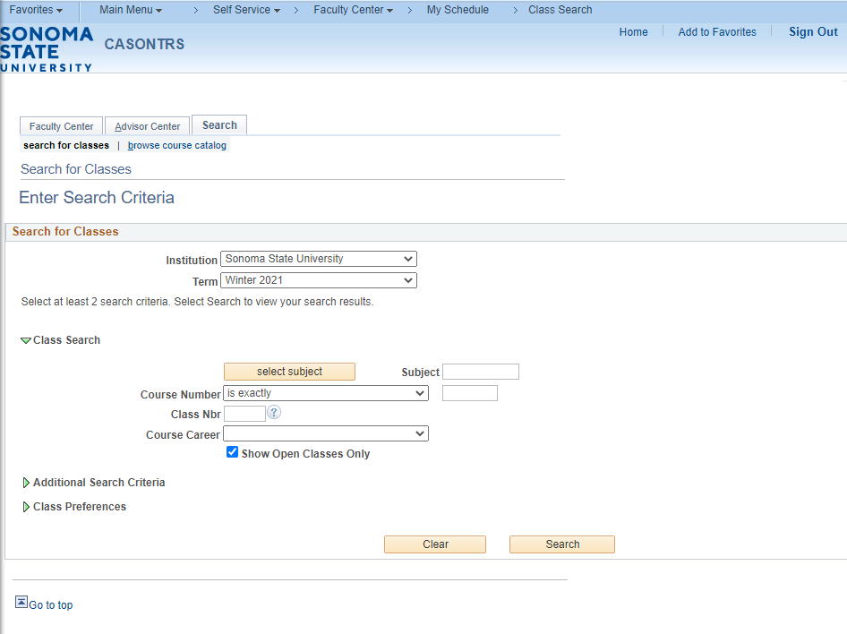
On the Class Search page, you will want to do the following:
- Institution will default to Sonoma State University
- Select the appropriate term from the drop-down menu
- Select the Subject – If you know the subject code (e.g. MATH, ENGL, COMS, etc.), enter it in the box. If you do not know the subject code, click the Select Subject button. Find the discipline you want and press the Select link.
- For the Course Number, if you are searching for a specific course number (e.g. 101, 395, etc.) enter it in the box. If you are searching for all classes within a discipline leave the course number field empty.
- For the Course Career, you can narrow the search results of a discipline search by selecting Undergraduate, Postbaccalaureate, or Extended Education from the drop-down menu.
- For the Show Open Classes Only checkbox, leave this checked to show only classes with seats available. Uncheck it to show closed or waitlisted courses as well.
- Click the Search button at the bottom of the page.
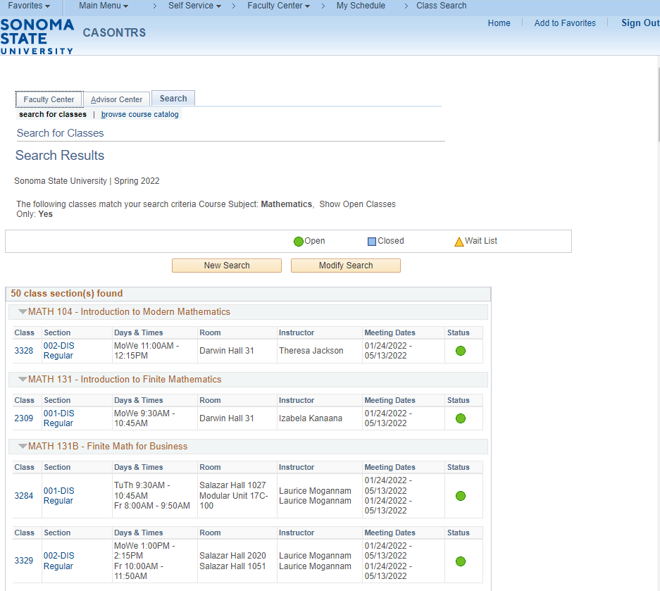
On the Class Search Results page:
- The course number and title will appear above all the sections of the class. Within the box, you will see the section number and 4-digit class number.
- A Green Dot on the right of the box indicates the class still has seats available.
- A Yellow Triangle on the right of the box indicates the class is in waitlist status.
- A Blue Box on the right of the box indicates the class is full, no seats are available and no waitlist is available.
- To learn more about the class, click on the section link, example: 002-DIS Regular.
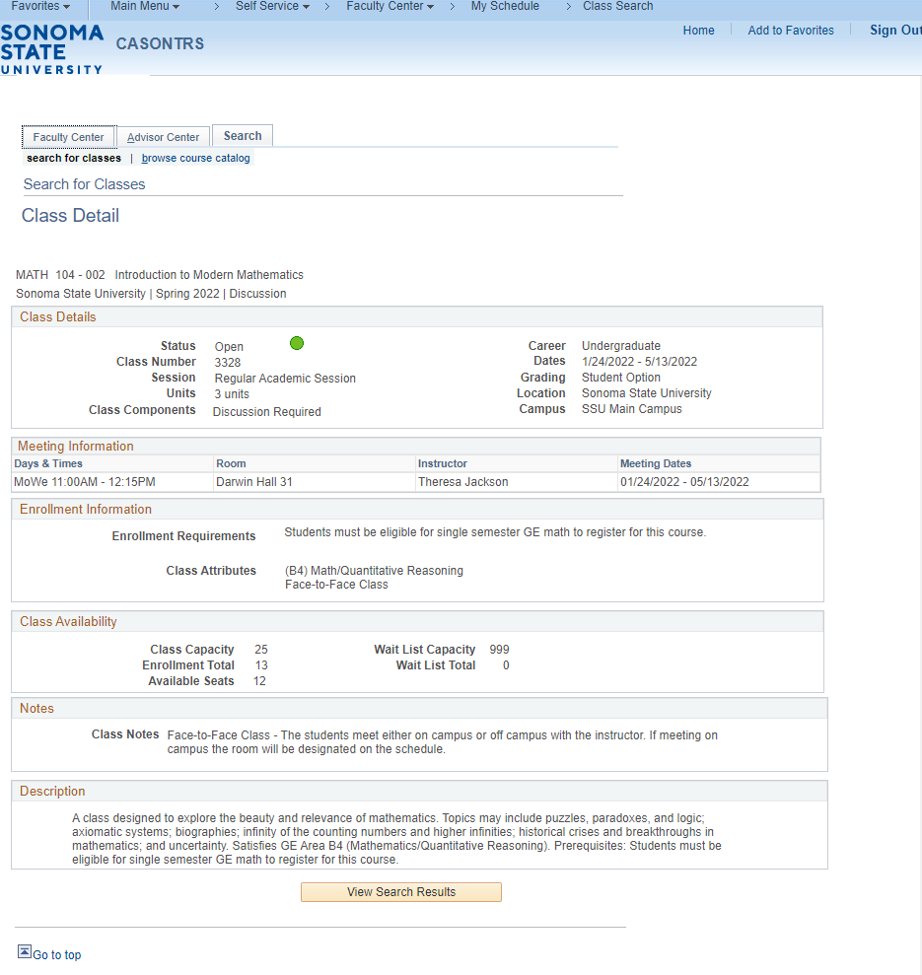
The Class Detail page will give you more details on the class such as: enrollment info, class availability, notes, description, and textbook info.
To review another class, click on the View Search Results button at the bottom of the page followed by the New Search button on the Class Search Results page.

