Authorize to Release BPG

OBJECTIVE
To provide guidance on how to use the Authorize to Release functionality in PeopleSoft to users and functional leads.
PEOPLESOFT CATEGORY: Campus Community
TABLE OF CONTENTS
Background & Purpose 3
Setup 3
Adding Designees 6
Adding Your First Designee 6
Adding Additional Designees 11
Extending a Designee’s Access 14
Removing a Designee 16
Viewing Authorizations 16
Related Content 18

If you have additional questions about the instructions and information in this process guide, please go to the Common Management Systems section of the IT Staff Directory on the Sonoma State website to find a staff resource.
For other guides, visit CMS How-Tos & FAQs.
If you encounter an accessibility problem with this document, please report an accessibility problem on the Sonoma State website.
Please note: to access the hyperlinks in this document, hold down CTRL on your keyboard while you click the link.

Background & Purpose
The Authorize to Release functionality was provided by the Chancellor’s office to standardize and facilitate the recordkeeping of authorizations to release FERPA-protected information to 3rd parties at the request of students. At SSU, this functionality replaced all existing paper forms effective January 11, 2021.

Setup
Navigation: CSU SA Baseline > CSU Campus Community > Authorization to Release > Setup > Authorization to Release Setup.
This page and the “Records to Be Released” page linked to at the bottom control all aspects of the Authorize to Release variables that control what students see on the Authorize to Release page, save the message catalogs.
Whenever you make changes to the Authorization to Release Options, add a new row on the page. Do not use “Correct History.”
You can set up the overall departments included in the list of departments on the student-facing Authorize to Release page and change the default department names. Checking the box next to a department name in the Department Category adds that Department to the list of Departments on the Authorize to Release page.
In the Rename Department fields, you can override the default Department names. Renaming the Department after the initial go-live is not recommended. The titles of departments are tied to the effective date of the page, so the department names will not update for existing records and may cause confusion.
For Sonoma State University’s initial setup, the effective date is set to 01/11/2021 and the Status set to A. The Display Authorization to Release link in Self Service is checked. Academic Records, Student Financial Services, Financial Aid, Admissions, and Housing are the departments selected for display. Academic Records is renamed to Office of the Registrar and Advising Programs and Student Financial Services is renamed to Seawolf Service Center & Student Financial Services.
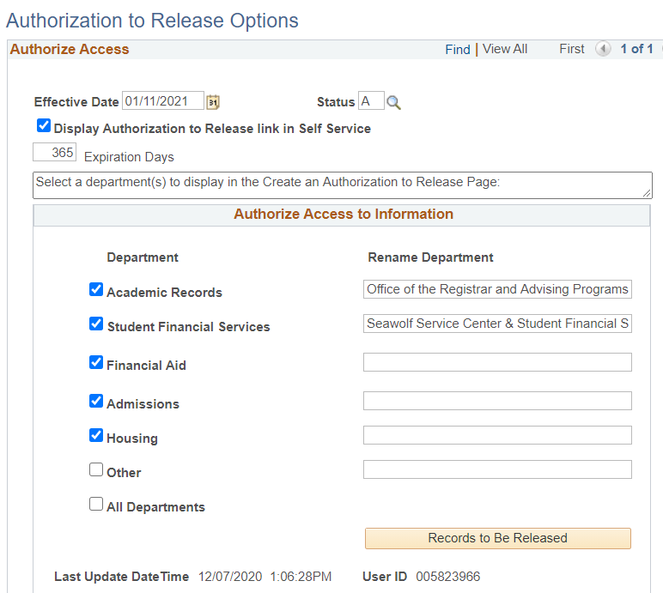
Now click on the Records to Be Released button. Under the Department drop-down, chose a department. Then, add a custom Records to Be Released title in the text field. Continue adding Departments and Records to Be Released titles until you have the full list as specified by the department heads. Unlike changing the Department Names, the titles of Records to Be Released can be edited at any time, and new rows can be added.
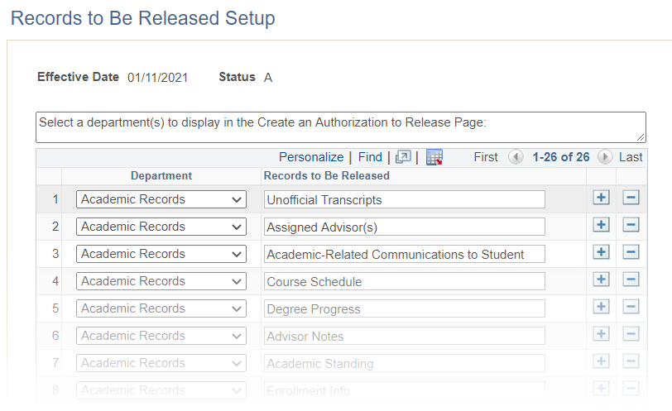
Click “OK” on the Records to Be Released page when you’re done. Click Save on the Authorization to Release Options page to save your changes and make them live.

Adding Designees

Adding Your First Designee
Log in to MySSU. From your Student Center click the "Authorize to Release" link under Personal Information near the bottom of the page:
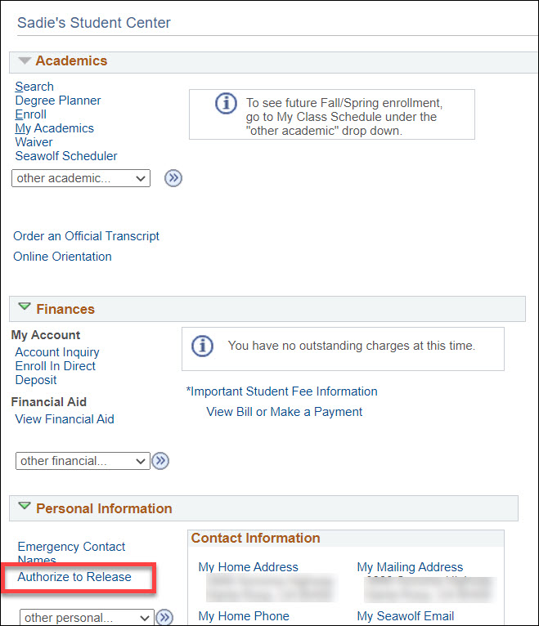
At the bottom of the page, enter the designee's first and last name. Create a 4 digit access code for them and enter an expiration date for their access:
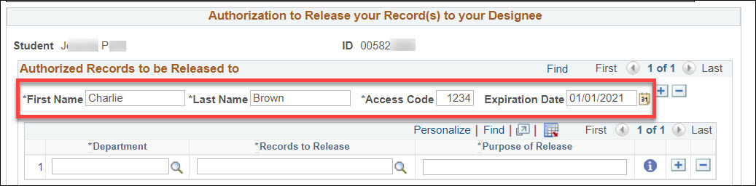
Then, choose a department. You can use the magnifying glass icon to search for available departments:
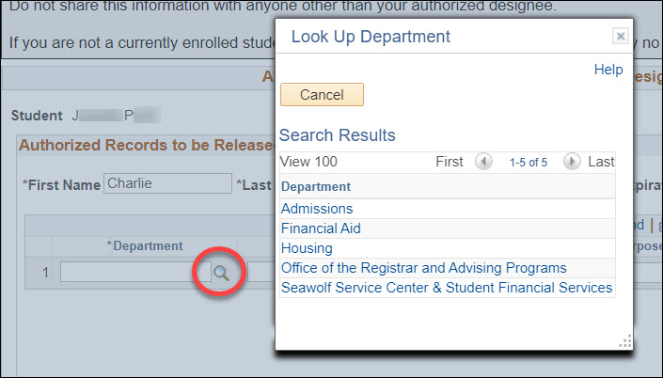
Once you’ve selected a department, select a record type to release. You can use the magnifying glass for a list:
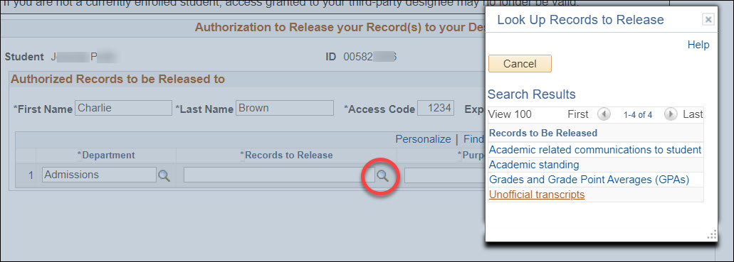
Add a purpose of release for your reference:
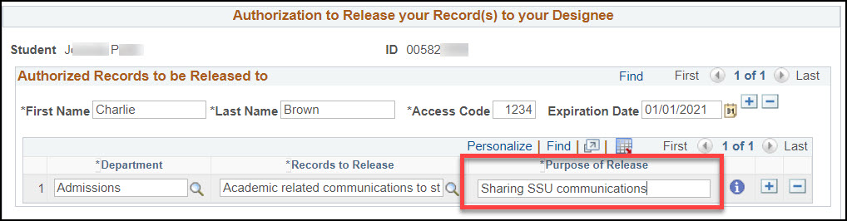
You can release more than one kind of record to an individual. Next to the “Purpose of Release” box, click the Add Row aka the plus button. This will create a new row under that individual’s name. Select a department and records to release, then add your purpose. You can add as many rows for an individual as you need to, but note that access to all records for the same person must expire at the same time.
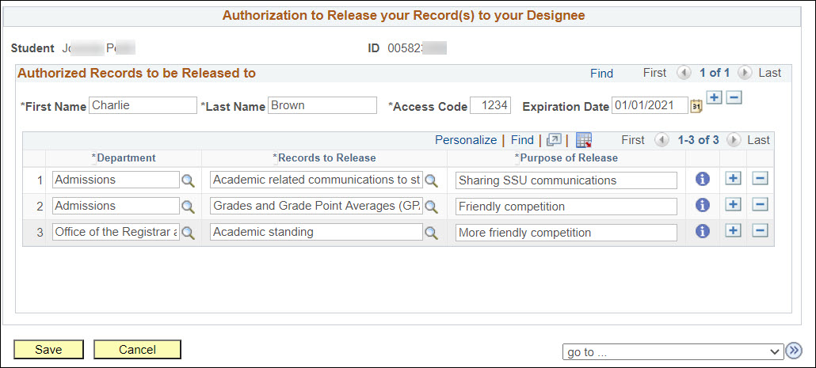
Click Save when you’re done.

Adding Additional Designees
If you have more than one individual you would like to allow to access your records, click the Add Row aka the plus button next to any expiration date. This will create a new blank entry for a different individual.
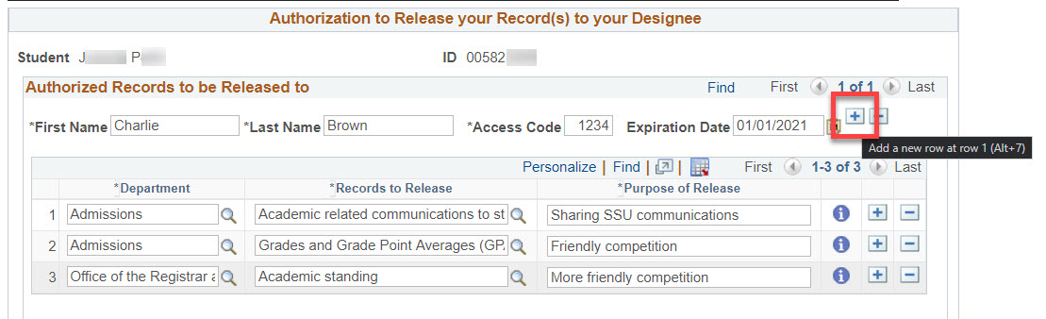
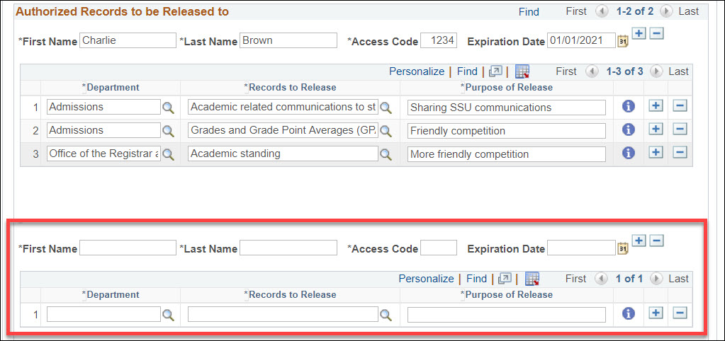
Fill in the information in the same way you did when you added your first designee:
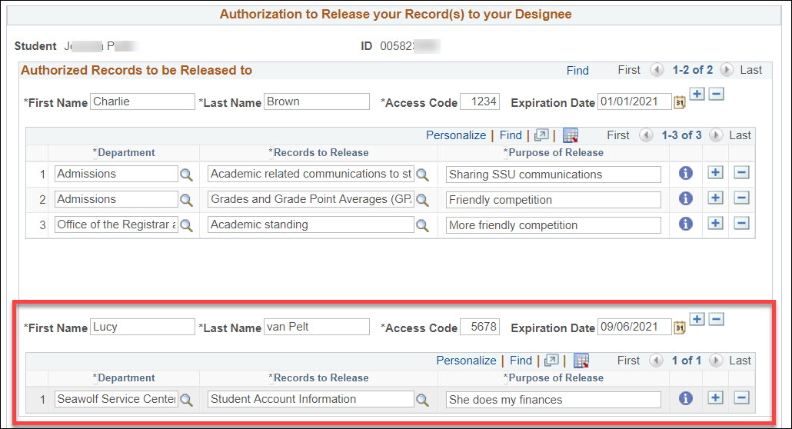
Click the Save button at the bottom of the page to save your changes.

Extending a Designee’s Access
Your authorizations will expire on the date you specify. To extend the period when a designee can access your records, simply update their Expiration Date.
On the Authorization to Release page, find the row for the designee you want. In the Expiration Date field, pick a new date within the next 365 days.
Pro tip: If you click the calendar icon, click “Current Date” and then use the year drop-down menu, you can easily extend the expiration date for a whole calendar year, in this case from 2020 to 2021:
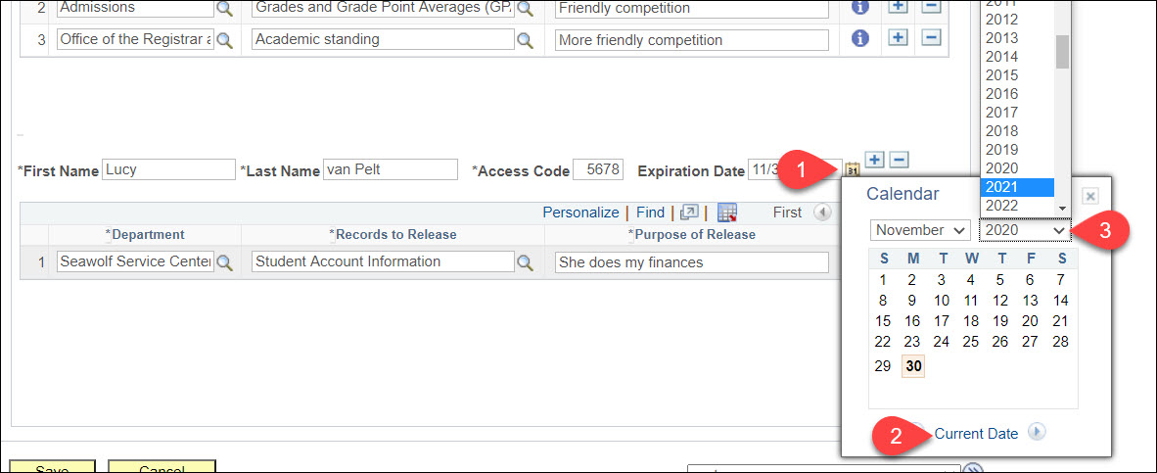
Click the Save button at the bottom of the page to save your changes.

Removing a Designee
On the Authorization to Release page, click "Delete Row" aka the minus button for any expired authorizations you do not intend to renew.
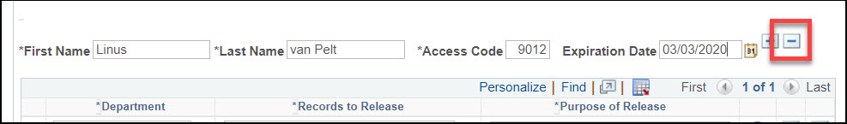
Click the Save button at the bottom of the page to save your changes.
Note: You cannot add the same designee (identical first name, last name combination) with different expiration dates.

Viewing Authorizations
Navigation: CSU SA Baseline > CSU Campus Community > Authorization to Release > Use > Authorize to Release - Admin.
Enter your search criteria and click “Search.” If you entered a complete student ID, you’ll go straight to that student’s Authorize to Release Information - Current Status page. Otherwise, click on the desired student from the search results.
On the Authorize to Release Information - Current Status page, you’ll see the student name and ID at the top. Just under that is the message catalog that displays to the student with a brief explanation of each department and their related records:
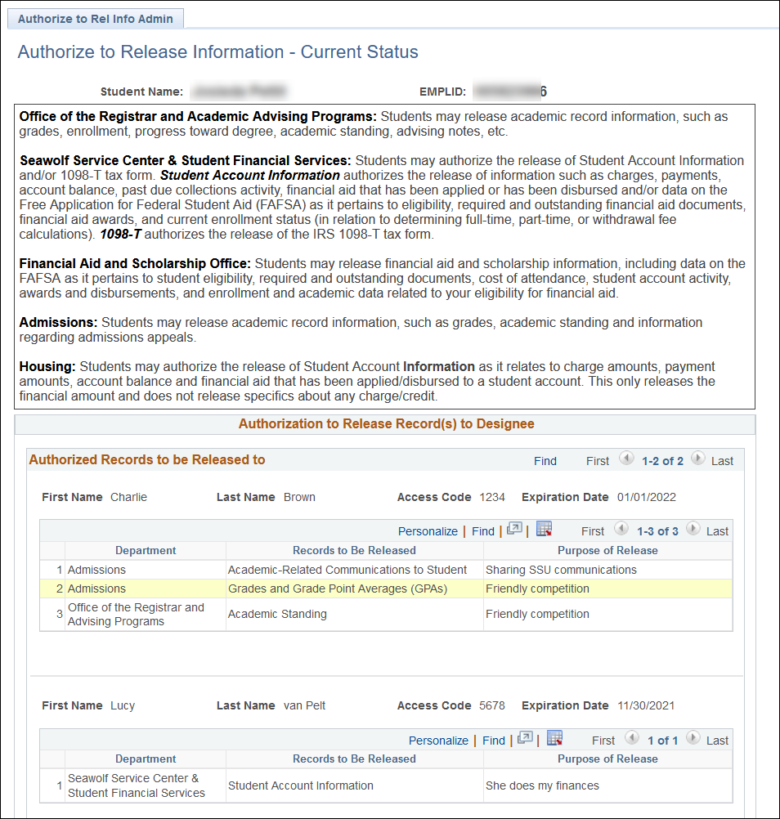
In the bottom section of this page, you can see the list of authorized 3rd-party designees, their Access Code, the expiration date, and which records they are authorized to access.
Note: Expired designees will display on this page. Always verify the expiration date is in the future before providing information to 3rd-party designees.
Before you release student information, the 3rd-party designee must:
- Identify themselves
- Provide the student’s name and ID
- Provide their access code
Here is a sample list of authorized individuals and which records they can request:

Related Content
Introduction: Related Content provides a way to view two pages in PeopleSoft at the same time.
Related Content has been created on several PeopleSoft pages so you can view student 3rd-party authorizations without navigating away from the page you’re on. For example, you can access student authorizations from the Student Financials > View Customer Accounts page.
In the upper right hand of the screen, click on “Related Content.” This will open a drop-down menu. Select “Authorize to Release.”
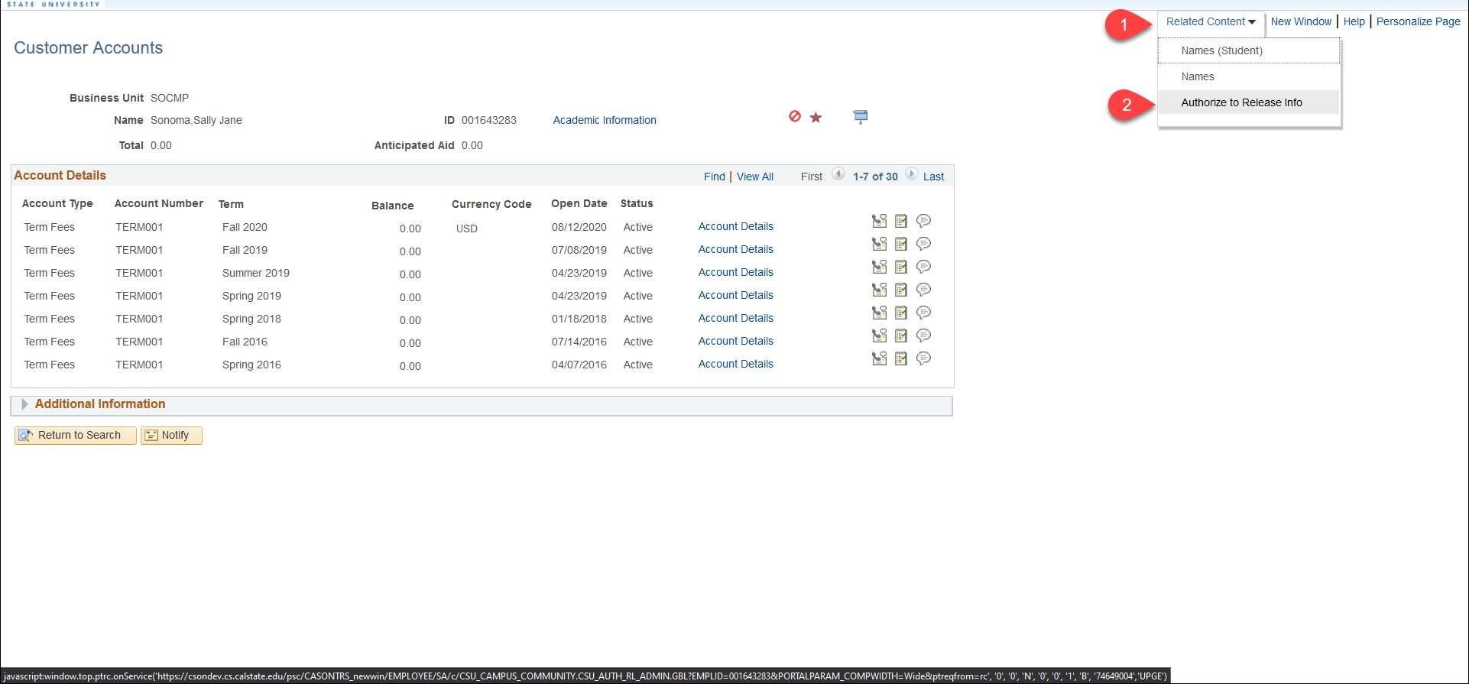
Now at the bottom of the page you can see the Authorize to Release Information - Current Status page for the student whose account you were viewing.
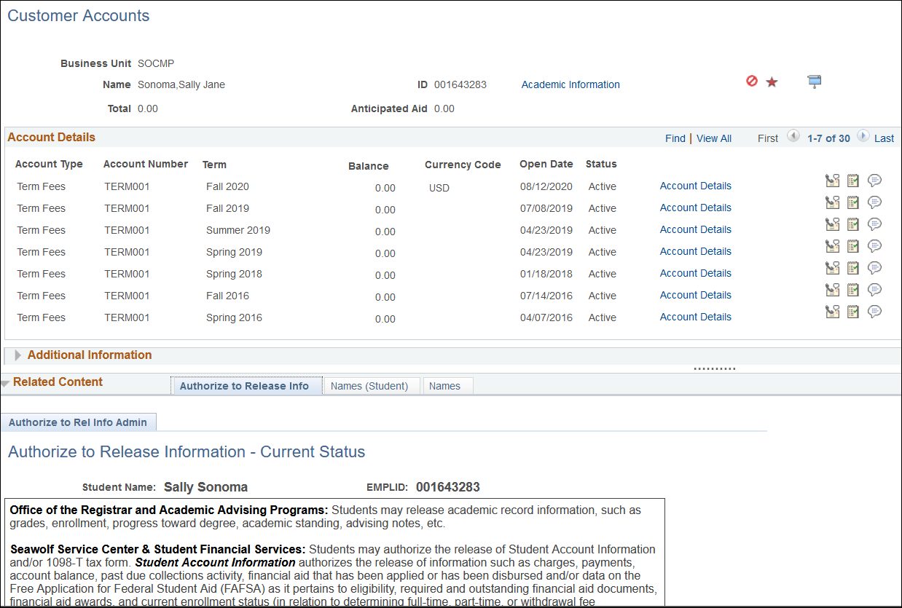
Just above the divider between the Customer Account view and the Authorize to Release Information - Current Status view is a series of 10 dots. If you hover over these dots, your cursor will change to double-headed vertical arrow. Click here and you can drag the divider up or down to see more or less of either window.
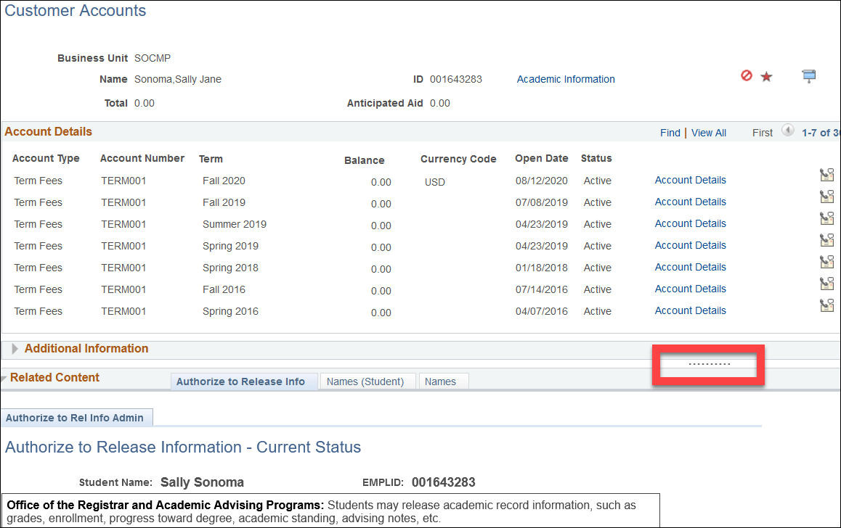
If you would like a Related Content link to the Authorize to Release Information – Current Status added to a PeopleSoft page where it doesn’t currently exist, contact the I.T. department.

