Assigning or Removing Advisors

OBJECTIVE
This document explains the steps involved in assigning, editing, and removing advisors and advisor committees for an individual student in MySSU.
MYSSU CATEGORY: Academic Advising
TABLE OF CONTENTS
Assigning or Removing Advisors 1
OBJECTIVE 1
Introduction 3
Lesson 1: Adding an Advisor 5
MySSU Navigation 5
Lesson 2: Adding an Advisor to a Student That Already Has an Advisor or Committee 7
MySSU Navigation 7
Lesson 3: Swapping or Removing an Academic Advisor 9
MySSU Navigation 9
Lesson 4: Important Steps for Adding or Removing Advising Committees 11
MySSU Navigation 11
Entering an Advising Committee on a Student Record 12

If you have additional questions about the instructions and information in this process guide, please go to the Common Management Systems section of the IT Staff Directory on the Sonoma State website to find a staff resource.
For other guides, visit CMS How-Tos & FAQs.
If you encounter an accessibility problem with this document, please report an accessibility problem on the Sonoma State website.
Please note: to access the hyperlinks in this document, hold down CTRL on your keyboard while you click the link.

Introduction
Students can be assigned an advisor (or many advisors). Advisor information is displayed in the Student Center in MySSU.
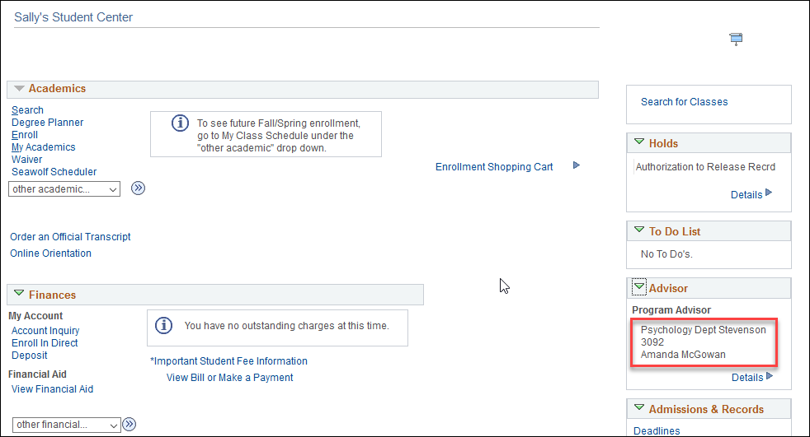
If the student clicks on the “Details” link in the Advisor box, they will see the academic program and major, if any, associated with each Advisor. Each advisor’s name is a link to send that advisor an email.
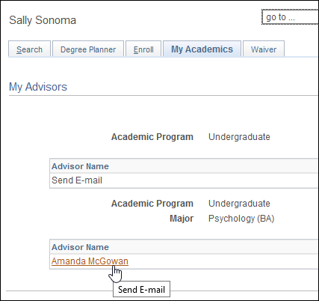
Faculty and Staff Advisors can see which students are assigned to them by logging into MySSU and going to the Advisor Center. The “My Advisees” list gives quick access to select a student and run an ARR, view a class schedule, email the student, and more advising functions.
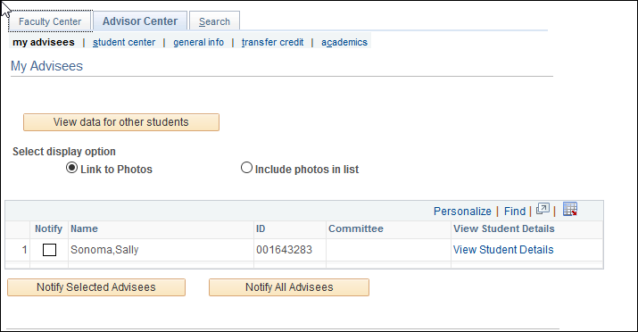

Lesson 1: Adding an Advisor
Introduction: The following steps will describe how to add an academic advisor to a student record.

MySSU Navigation
Main Menu > Records and Enrollment > Student Background Information > Student Advisor
- Navigate to the Student Advisor Page and use the search boxes to find the student’s record.
- If there is already a record of a current advisor, stop here and instead use Lesson 2.
- If there is no current advisor, use the magnifying glasses to select academic career, program, and plan. The Advisor Role field defaults to Advisor. Add the Academic Advisor’s ID or use the magnifying glass to search for the advisor.
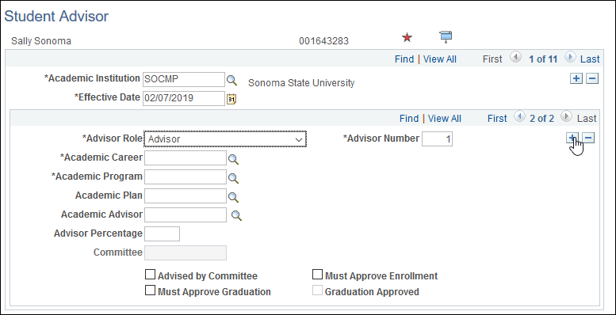
- If you are adding an advising committee, see Lesson 4 for more information.
- Use the lower of the two plus icons if you are adding more than one advisor (or advising committee) at the same time. This will add a new blank row. Fill in the information using the methods described in step 3.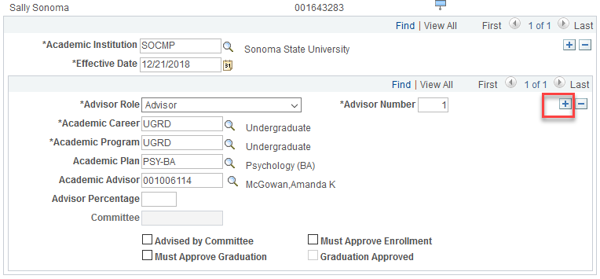
- Select the Save button to finalize your student advisor update.

Lesson 2: Adding an Advisor to a Student That Already Has an Advisor or Committee
Introduction: Students often may be receiving advising from multiple academic departments or advising teams (called “Committees” in MySSU) on campus. This lesson describes how to add an advisor to a student who has existing advising. If you are looking to add a new advisor and remove an old advisor at the same time please skip to Lesson 3.

MySSU Navigation
Main Menu > Records and Enrollment > Student Background Information > Student Advisor
- Navigate to the Student Advisor Page and use the search boxes to find the student’s record.
- Select the plus icon in the section with Academic Institution and Effective Date to add a new row of data.
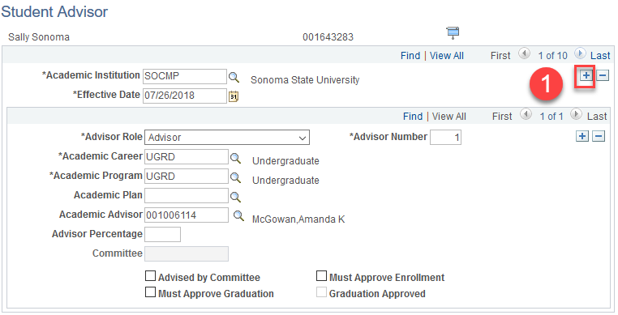
- Notice two things change. The page now reads “1 of 11” in the upper section instead of “1 of 10,” and the new row of data has today’s effective date. This is how we add new data without deleting the old data. The advising information you’re about to add is going to be overlaid upon previous records, as of today, like placing a new index card on top of an existing stack.
- Select the lower level plus icon in the lower section of the page.
- Note that the system has added a second set of data for this new advisor as indicated by the “2 of 2”.
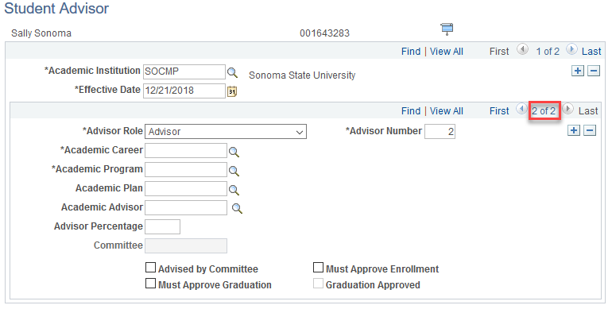
Use the left and right arrow icons to move between the multiple advisors, or click “View All” to display all advisors in a list.
- Use the magnifying glasses to select academic career, program, and plan. Add the Academic Advisor’s ID or use the magnifying glass to search for the advisor. Select the Save button to finalize your student advisor update.

Lesson 3: Swapping or Removing an Academic Advisor
Introduction: Students often change majors/minors. This lesson describes a direct swap scenario where the student had a previous advisor assigned but the student is no longer a part of that major. A new advisor must be added, and the prior advisor removed.

MySSU Navigation
Main Menu > Records and Enrollment > Student Background Information > Student Advisor
- Select the plus icon in the section with Academic Institution and Effective Date to add a new row of data.
- Notice two things change. The page now reads “1 of 11” in the upper section instead of “1 of 10,” and the new row of data has today’s effective date. This is how we add new data without deleting the old data. The advising information you’re about to add is going to be overlaid upon previous records, as of today, like placing a new index card on top of an existing stack.
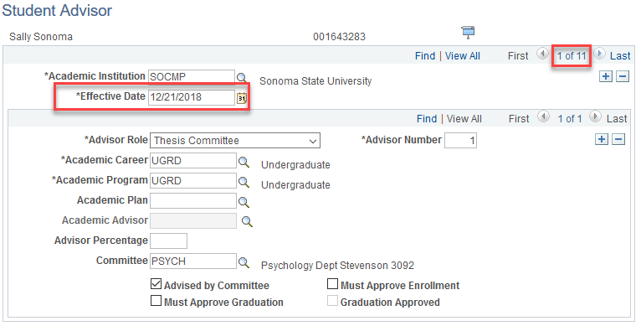
Note: do not change the effective date.
- On this new page, delete the old advisor and plan. In the scenario illustrated here, the previous advisor was a “committee,” and we want to add an individual advisor. To do so, change the Advisor Role back to Advisor from Thesis Committee and uncheck the box for “advised by committee”. This will activate the Academic Advisor field and deactivate the Committee field.
- Use the magnifying glasses to select academic career, program, and plan. Add the Academic Advisor’s ID or use the magnifying glass to search for the advisor. 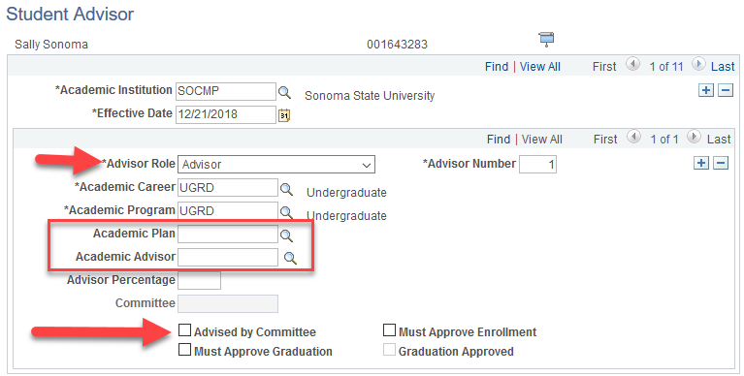
- Select the Save button to finalize your student advisor update.

Lesson 4: Important Steps for Adding or Removing Advising Committees
Introduction: Students often have an assigned advising “committee”. Here are some frequently asked questions and tips when adding/removing Advising Committees.

MySSU Navigation
Main Menu > Records and Enrollment > Student Background Information > Student Advisor
An example of a commonly used advising committee is the Advising Office for undeclared students. The name of the committee reads “Undeclared Office Schulz 1125a” in the Student Center. Unlike an individual advisor, the student cannot use the “Details” link to find a contact email address.
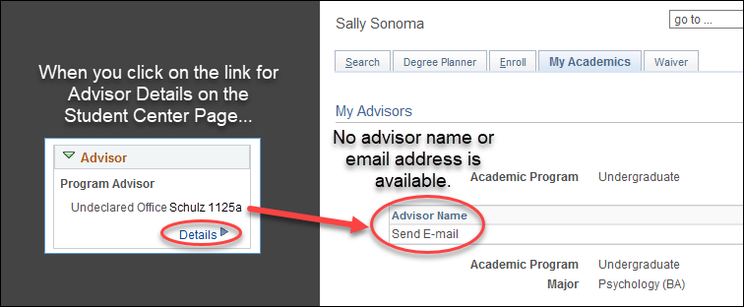

Entering an Advising Committee on a Student Record
There are three fields that allow you to add an Advising Committee.
- An Advisor Role of “Thesis Committee”
- A checked “Advised by Committee” checkbox.
- The Committee short code.
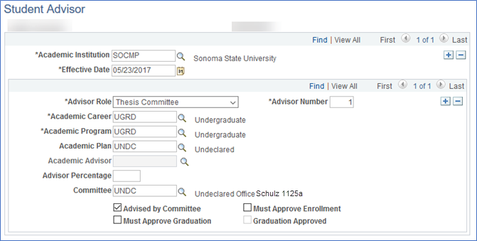
Note that the Academic Advisor field has been greyed out, indicating you cannot have both a committee and an individual advisor on the same row of data.
The Academic Career, Academic Program, and plan if applicable still need to be filled out.
To add an additional advisor, whether it be an individual or another committee, you must always add a new row of data to make the “effective date” current. To do so, select the plus icon in the upper section alongside Academic Institution and Effective Date. Then, select the lower level plus icon to add a new row. Now you have blank fields where you can enter the new advisor/advising committee data. It is important that each advisor (or advising committee) each have their own separate row of data in the lower section.
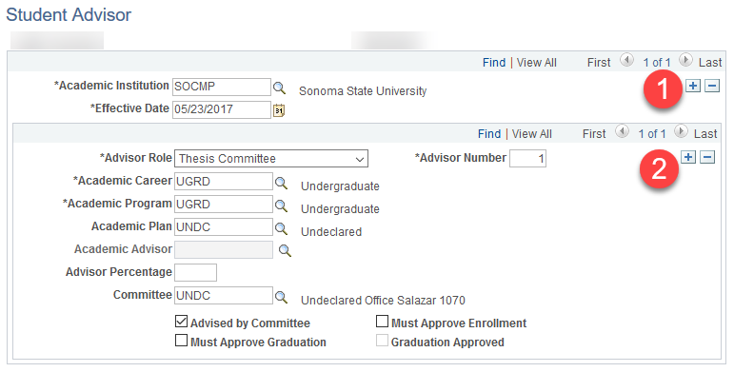
Note the “1 of 2” for the effective dates in the top section. This means you’ve put a new record on top of the old record, rather than deleting the old.
Also note the “2 of 2” in the Advisors section.
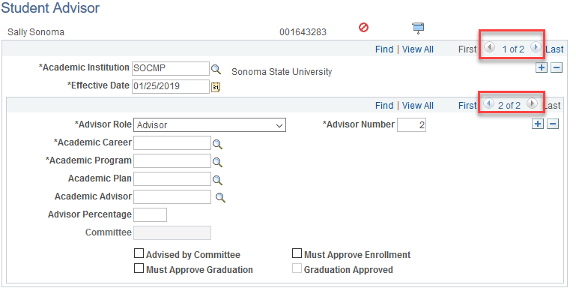
This indicates that the student will now see two advisors in their student center.
