Advisor Notes

A brief overview of the Advisor Notes function in MySSU
PEOPLESOFT CATEGORY: Academic Advising

TABLE OF CONTENTS
Advisor Notes 1
Lesson 1: Advisor Notes Overview 2

If you have additional questions about the instructions and information in this process guide, please go to the Common Management Systems section of the IT Staff Directory on the Sonoma State website to find a staff resource.
For other guides, visit CMS How-Tos & FAQs.
If you encounter an accessibility problem with this document, please report an accessibility problem on the Sonoma State website.
Please note: to access the hyperlinks in this document, hold down CTRL on your keyboard while you click the link.

Lesson 1: Advisor Notes Overview
Introduction: This document details how to view existing notes or add new notes to a student ID in MySSU
- Navigate to the Advisor Center in MySSU
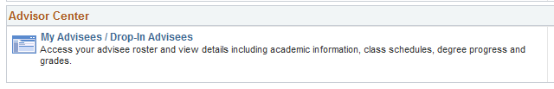
- On the My Advisees tab select “View Data for Other Students”
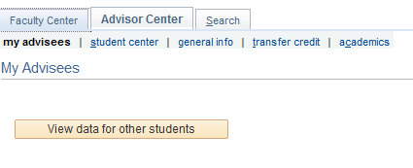
- Search for the student
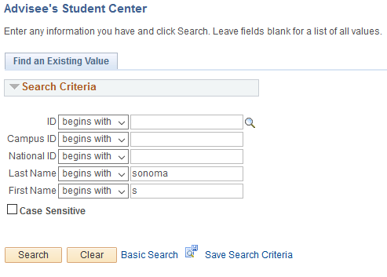
- Select Advisor Notes from the Academic drop-down menu
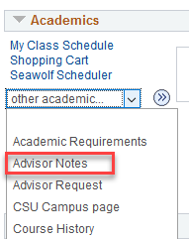
- If the student already has a note, select the blue plus sign in the right-hand corner to add a new note
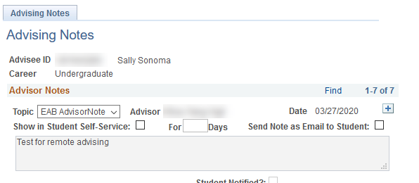
- Select an appropriate topic from the “Topic” drop-down menu
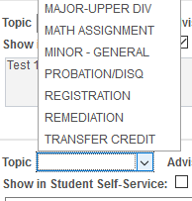
- The “Show in Student Self-Service” checkbox should only be selected if you want the student to see your note on the ARR. If this box is left unchecked, it will still be visible by all advisors
Note: All advising notes entered under this system are considered part of the student’s record under FERPA regulations. Be aware that even if an advisor selects not to have a note available to the student through Self-Service, the student may file a request and be allowed to view all notes.
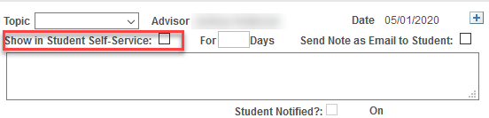
- Enter how many days you would like the student to be able to view this note on their ARR. I no end-date exists, select 999 days.
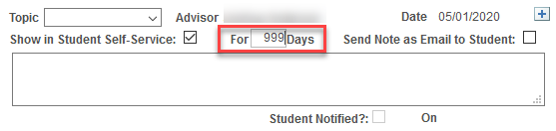
- If you would like the note to be emailed to the student, select this checkbox.
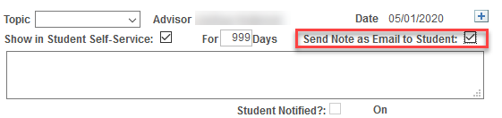
- Enter your advising notes in the free-form text box.
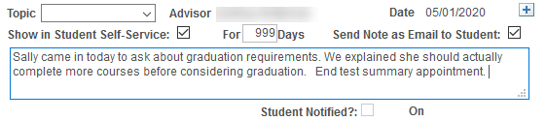
- Once you hit apply the note will no longer be editable or removable. Once ready, select Apply.

In regards to Advisor Notes, you should know that:
- Any faculty or advisor with access to Advisor Notes can see any note that you make in Advisor Notes
- You can see any other notes that any another advisor on campus has made for a student
- Students can only see the note on their ARR if you check that “Show in Student Self-Service” box and indicate how many days it should show
- Advisor Notes are an official part of a students’ record, so they can be used in a court of law (not meant to scare you, but you should know!)
- You can’t make a note for a student who is no longer in attendance at the University

