Advisor Change Process: Batch Add, Remove or Swap Student Advisors
MYSSU CATEGORY: Academic Advising
TABLE OF CONTENTS
Introduction 3
Lesson 1: Add an Advisor to a Batch of Students via File 4
MySSU Navigation 4
Instructions 4
Lesson 2: Add an Advisor to a Batch of Students via Query 8
MySSU Navigation 8
Instructions 8
Lesson 3: Remove Students from an Advisor Using an External File 12
MySSU Navigation 12
Instructions 12
Lesson 4: Remove a Batch of Students Using a Query 16
MySSU Navigation 16
Instructions 16
Lesson 5: Swap a Batch of Students from One Advisor to Another 20
MySSU Navigation 20
Instructions 20
Lesson 6: Available Queries 24

If you have additional questions about the instructions and information in this process guide, please go to the Common Management Systems section of the IT Staff Directory on the Sonoma State website to find a staff resource. For other guides, visit CMS How-Tos & FAQs.
If you encounter an accessibility problem with this document, please report an accessibility problem on the Sonoma State website.
Please note: to access the hyperlinks in this document, hold down CTRL on your keyboard while you click the link.

Introduction
An Advisor can be assigned to any student in MySSU. This Advisor will display in the MySSU Student Center for a student to see whenever they log in. When an advisor logs into MySSU, a list of their Advisees will display in the Advisor Center.
Departments can run reports to find out how many students are assigned to a particular advisor. Log in to MySSU and navigate to Records and Enrollment > Student Background Information > Student Advisor to search for a student and see if they have an advisor assigned. Selecting a student takes you to their Student Advisor page. Here, you can add a new advisor. You may or may not be able to remove an already assigned advisor, depending on your security.
Using batch processes will enable you to update more than one student at a time. You can run reports to find students that have left your major or minor and remove the advisors associated with those students. This process can also remove one advisor from a large number of students in a case where the advisor has left SSU or is on leave.
Another feature of this process is a “Swap”. If you have an advisor that will be taking on the advising load for someone else, you can swap the original advisor for the new one in one process.

Lesson 1: Add an Advisor to a Batch of Students via File
Introduction: Follow the steps below to upload a .CSV file with a list of students by ID and add an advisor to those students.
This lesson will show you how to create a .csv file with student IDs, navigate to the Student Advisor Update page in MySSU, upload the file, fill in the necessary fields, and run the process.

MySSU Navigation
SON Customizations > SON Campus Solutions > Advising > Process > Student Advisor Update

Instructions
- Create a .CSV file with a line for each student ID in the third column, You can leave the first two columns blank. Do NOT include any headers or text other than the student IDs
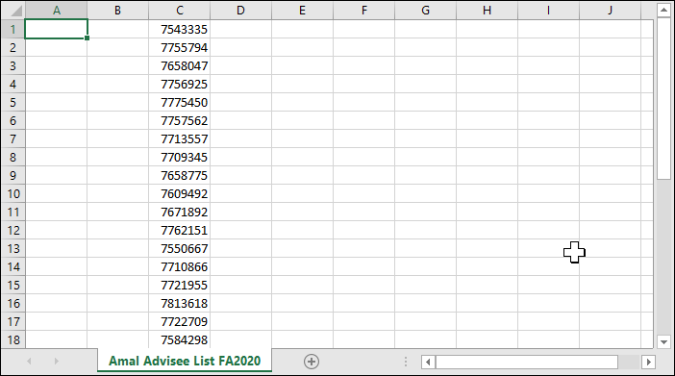
You can create a .CSV file from an Excel spreadsheet by going to “Save As” and changing the Save as file type to “CSV (Comma delimited).
Note: All students in your list must be in the same Academic Career and Academic Program. If you have a mixed population, you need to run the process separately for each group.
- Log into MySSU and navigate to SON Customizations > SON Campus Solutions > Advising > Process > Student Advisor Update.
- If you have not yet created a run control for this process, create a new one. If you have a run control set up, search for and select the existing run control.
- In Selection Tool under Population Selection, pick External File.
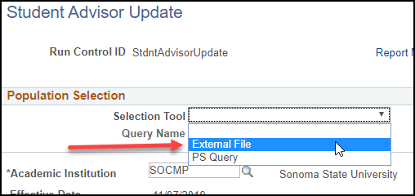
- Click the Upload File button. Click Choose File, locate the .CSV file from step one on your computer or network, and click Upload. The name of the file will now appear in the Attached File line.
- In the File Mapping box, click the magnifying box to the right and click SON STUDENT ADVISOR UPDATE from the search results.
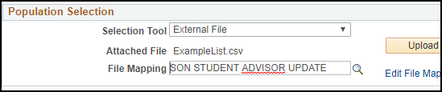
- Click the “Preview Selection Results” link to see up to the first three hundred Student IDs from your file. If you do not see the list of students you expect, contact a member of the CMS department to troubleshoot.
- Click Return.
- SOCMP will auto-fill the Academic Institution field.
- Enter the Academic Career and Academic Program in the next two fields.
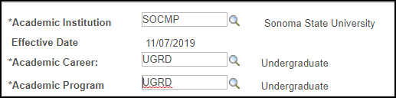
- Under the ADD Section header, enter the students’ Academic Plan.
- If you are adding an individual advisor, select Advisor as the Advisor Role and enter the advisor’s ID in the Academic Advisor field.
- If you are adding an advising committee, change the Advisor Role to Thesis Committee, check the Advised by Committee box, and fill the Committee field.
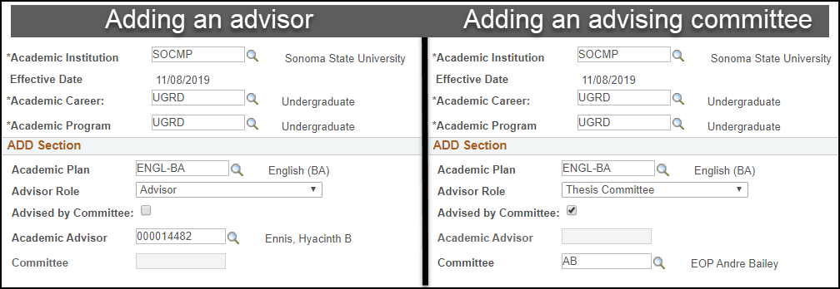
- Click the Save button at the lower left.
- Click the Run button in the upper right, which brings you to the Process Scheduler Request page.
- Click OK or hit Enter on your keyboard. This will bring you back to the previous screen, the Student Advisor Update page.
- Click the Process Monitor link.
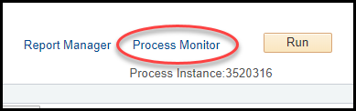
- On the Process Monitor page, click Refresh until the Distribution Status reads Posted.
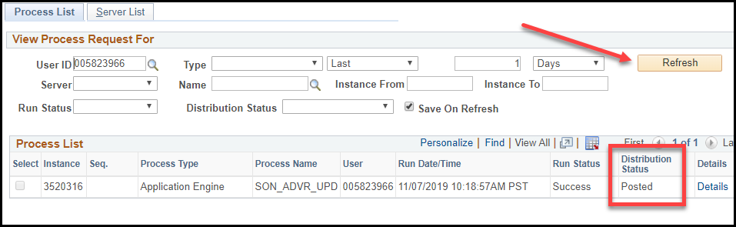
Note: If your Run Status does not say Success, the process has failed. The most common reason is an error in the file upload. Check to make sure each ID is on a single line and there are no words in the file. Then, try again.
- Click the Details link in the process row when the process has posted.
- Click View Log/Trace, then click the .log file in the File List.
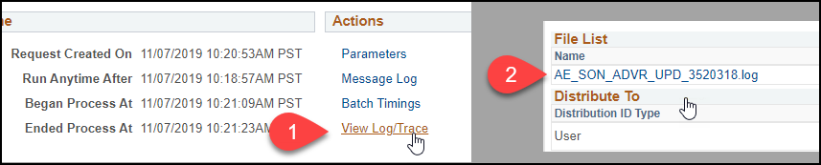Read this report to find out which students were processed successfully and which students were not. If they were not processed successfully, the log will include a brief description why.
- If you need to run another batch, click the Go Back to Student Advisor Update link near the bottom of the Process Monitor page. Otherwise, you are done.

Lesson 2: Add an Advisor to a Batch of Students via Query
Introduction: Follow the steps below to identify students by query and add an advisor to those students.
This lesson will show you how to navigate to the Student Advisor Update page in MySSU, choose a query that targets the intended students, fill in the necessary fields, and run the process. For a list of the queries available to you, see Lesson 6: Available Queries.

MySSU Navigation
SON Customizations > SON Campus Solutions > Advising > Process > Student Advisor Update

Instructions
Note: All students in your query need to be in the same Academic Career and Academic Program. If you have a mixed population, you need to run the process separately for each group.
- Log into MySSU and navigate to SON Customizations > SON Campus Solutions > Advising > Process > Student Advisor Update.
- If you have not yet created a run control for this process, create a new one now. If you have a run control set up, search for and select the run control you created.
- In Selection Tool under Population Selection, select PS Query.
- Click the magnifying glass and select your query.
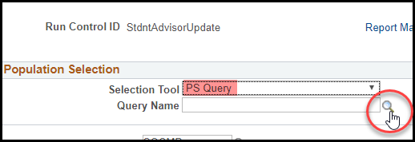
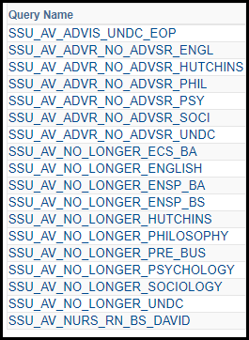
- Click Preview Selection Results and check for accuracy. Note that the query will not return all results in this window, just the first three hundred.
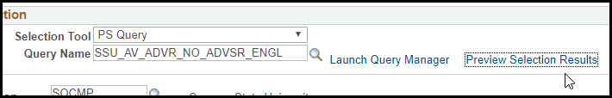
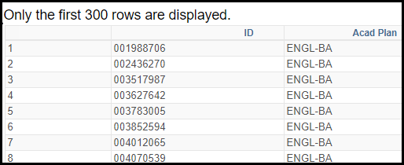
- Click Return to continue setting parameters for the process.
- SOCMP will auto-fill the Academic Institution field.
- Enter the Academic Career and Academic Program in the next two fields.
- Under the ADD Section header, enter the Academic Plan.
- If you are adding an individual advisor, select Advisor as the Advisor Role and enter the advisor ID in the Academic Advisor field.
- If you are adding an advising committee, change the Advisor Role to Thesis Committee, check the Advised by Committee box, and fill the Committee field.
- Click the Save button at the lower left.
- Click the Run button in the upper right, which brings you to the Process Scheduler Request page.
- Click OK or hit Enter on your keyboard. This will bring you back to the previous screen, the Student Advisor Update page.
- Click the link to the Process Monitor.
On the process monitor page, click Refresh until the Distribution Status turns to Posted.
Note: If your Run Status does not say Success, the process has failed for some reason. See steps 17 and 18 for help troubleshooting.
- Click the Details link in the process row when the process has posted.
- Click View Log/Trace and click the .log file in the File List. You can read this report to find out which students were processed successfully and which students were not. If they were not processed, the log will include a brief description of why.
- If you need to run another batch, click the Go Back to Student Advisor Update link near the bottom of the Process Monitor page. Otherwise, you are done.

Lesson 3: Remove Students from an Advisor Using an External File
Introduction: Follow the steps below to upload a .CSV file with a list of students by ID and remove an advisor from those students, leaving the historical record of the advisor in place but inactive. Note that if this process removed an advisor for a student who only had one advisor, the student will now have a NONE row inserted on the Student Advisor page.

MySSU Navigation
SON Customizations > SON Campus Solutions > Advising > Process > Student Advisor Update

Instructions
- Create a .CSV file with a line for each student ID in the third column, You can leave the first two columns blank. Do NOT include any headers or text other than the student IDs
You can create a .CSV file from an Excel spreadsheet by going to “Save As” and changing the Save as file type to “CSV (Comma delimited).
Note: All the students in your list need to be in the same Academic Career and Academic Program. If you have a mixed population, you will need to run the process separately for each group.
- Log into MySSU and navigate to SON Customizations > SON Campus Solutions > Advising > Process > Student Advisor Update.
- If you have not yet created a run control for this process, create a new one now. If you do have a run control set up, search for and select the run control you created.
- In the Selection Tool under Population Selection, pick the External File option.
- Click the Upload File button. Click Choose File, locate the .CSV file from step one on your computer or network and click Upload. The name of the file will now appear in the Attached File line.
- In the File Mapping box, click the magnifying box to the right and click SON STUDENT ADVISOR UPDATE from the search results.
- Click the “Preview Selection Results” link to see up to the first three hundred Student IDs from your file. If you do not see the list of students you expect, contact a member of the CMS department to troubleshoot.
- Click Return.
- SOCMP will auto-fill the Academic Institution field.
- Enter the Academic Career and Academic Program in the next two fields.
- Skip the fields under the ADD Section header and proceed to the DELETE Section.
- If you are removing an individual advisor, select Advisor as the Advisor Role and enter the advisor ID in the Academic Advisor field.
- If you are instead removing an advising Committee, change the Advisor Role to Thesis Committee, check the Advised by Committee box, and fill the Committee field.
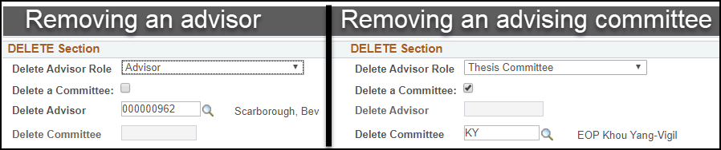
- Click the Save button at the lower left.
- Click the Run button in the upper right, which brings you to the Process Scheduler Request page.
- Click OK or hit Enter on your keyboard. This will bring you back to the previous screen, the Student Advisor Update page.
- Click the link to the Process Monitor.
On the process monitor page, click the Refresh button until the Distribution Status turns to Posted.
Note: If your Run Status does not say Success, the process has failed. The most common reason is an error in the text file upload. Check to make sure each ID is on a single line and there are no words in the file.
- Click the Details link in the process row when the process has posted.
- Click View Log/Trace and click the .log file in the File List. You can read this report to find out which students were processed successfully and which students were not. If they were not processed, the log will include a brief description of why.
- If you need to run another batch, click the Go Back to Student Advisor Update link near the bottom of the Process Monitor page. Otherwise, you are done.

Lesson 4: Remove a Batch of Students Using a Query
Introduction: Follow the steps below to use a query to find a list of students by ID and remove an advisor from those students, leaving the historical record of the advisor in place but inactive. Note that if this process removed an advisor for a student who only had one advisor, the student will now have a NONE row inserted on the Student Advisor page. For a list of the queries available to you, see Lesson 6: Available Queries.

MySSU Navigation
SON Customizations > SON Campus Solutions > Advising > Process > Student Advisor Update

Instructions
Note: All the students targeted in your query need to be in the same Academic Career and Academic Program. If you have a mixed population, you will need to run the process separately for each group.
- Log into MySSU and navigate to SON Customizations > SON Campus Solutions > Advising > Process > Student Advisor Update.
- If you have not yet created a run control for this process, create a new one now. If you have a run control set up, search for and select the run control you created.
- In the Selection Tool under Population Selection, pick the PS Query option.
- Click the magnifying glass and select your query.
- Click Preview Selection Results and check that they look accurate. Note that the query will not return all results in this window, just the first three hundred.
- Click Return to continue setting parameters for the process.
- SOCMP will auto-fill the Academic Institution field.
- Enter the Academic Career and Academic Program in the next two fields.
- Skip the fields under the ADD Section header and proceed to the DELETE Section.
- If you are removing an individual advisor, select Advisor as the Advisor Role and enter the advisor ID in the Academic Advisor field.
- If you are instead removing an advising committee, change the Advisor Role to Thesis Committee, check the Advised by Committee box, and fill the Committee field.
- Click the Save button at the lower left.
- Click the Run button in the upper right, which brings you to the Process Scheduler Request page.
- Click OK or hit Enter on your keyboard. This will bring you back to the previous screen, the Student Advisor Update page.
- Click the link to the Process Monitor.
On the Process Monitor page, click the Refresh button until the Distribution Status turns to Posted.
Note: If your Run Status does not say Success, the process has failed for some reason. See steps 17 and 18 for help.
- Click the Details link in the process row when the process has posted.
- Click View Log/Trace and click the .log file in the File List. You can read this report to find out which students were processed successfully and which students were not. If they were not processed, the log will include a brief description of why.
- If you need to run another batch, click the Go back to Student Advisor Update link near the bottom of the Process Monitor page. Otherwise, you are done.

Lesson 5: Swap a Batch of Students from One Advisor to Another
Introduction: Follow the steps below to identify students by query or uploaded file and simultaneously add an advisor to those students and remove an existing advisor. For a list of the queries available to you, see Lesson 6: Available Queries.
Note: All the students targeted in your query need to be in the same Academic Career, Academic Program, and Academic Plan. If you have a mixed population in any of these aspects, you will need either to run this process separately for each group (if they differ in Career or Program) or run one process to remove plus one process to add an advisor.

MySSU Navigation
SON Customizations > SON Campus Solutions > Advising > Process > Student Advisor Update

Instructions
- Log into MySSU and navigate to SON Customizations > SON Campus Solutions > Advising > Process > Student Advisor Update.
- If you have not yet created a run control for this process, create a new one now. If you do have a run control set up, search for and select the run control you created.
- EITHER follow the steps to upload a .CSV file or follow the steps to use a query. See Lessons 1 for instructions on using a .CSV file and Lesson 2 for instructions on using a query.
- If you are swapping a single advisor:
  - Fill in the Academic Career and Academic Program.
  - Under the ADD Section, select the appropriate Academic Plan and set the Advisor Role to Advisor. Enter the new advisor’s ID in the Academic Advisor field.
  - Under the DELETE Section, set the Advisor Role to Advisor and enter the current advisor’s ID in the Academic Advisor field.
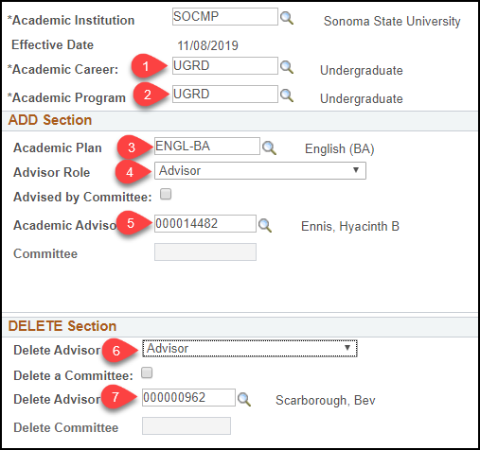
- If you are swapping an advising committee:
  - Fill in the Academic Career and Academic Program.
  - Under the ADD Section, select the appropriate Academic Plan and set the Advisor Role to Thesis Committee. Check the Advised by Committee box and enter the new committee’s ID in the Committee field.
  - Under the DELETE Section, set the Advisor Role to Thesis Committee. Check the Advised by Committee box and enter the current committee’s ID in the Academic Advisor field.
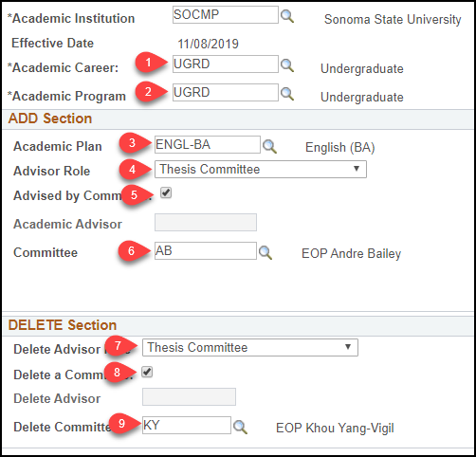
- Click the Save button at the lower left.
- Click the Run button in the upper right, which brings you to the Process Scheduler Request page.
- Click OK or hit Enter on your keyboard. This will bring you back to the previous screen, the Student Advisor Update page.
- Click the link to the Process Monitor.
On the Process Monitor page, click the Refresh button until the Distribution Status turns to Posted.
Note: If your Run Status does not say Success, the process has failed for some reason. See steps 10 and 11 for help.
- When the process has posted, click the Details link in the process row.
- Click View Log/Trace and click the .log file in the File List. You can read this report to find out which students were processed successfully and which students were not. If they were not processed, the log will include a brief description of why.
- If you need to run another batch, click the Go back to Student Advisor Update link near the bottom of the Process Monitor page. Otherwise, you are done.

Lesson 6: Available Queries
As of the date of this process guide, the queries you can use in this process are as follows:
- SSU_AV_ADVIS_UNDC_EOP
- SSU_AV_ADVR_NO_ADVSR_ENGL
- SSU_AV_ADVR_NO_ADVSR_HUTCHINS
- SSU_AV_ADVR_NO_ADVSR_PHIL
- SSU_AV_ADVR_NO_ADVSR_PSY
- SSU_AV_ADVR_NO_ADVSR_SOCI
- SSU_AV_ADVR_NO_ADVSR_UNDC
- SSU_AV_NO_LONGER_ECS_BA
- SSU_AV_NO_LONGER_ENGLISH
- SSU_AV_NO_LONGER_ENSP_BA
- SSU_AV_NO_LONGER_ENSP_BS
- SSU_AV_NO_LONGER_HUTCHINS
- SSU_AV_NO_LONGER_PHILOSOPHY
- SSU_AV_NO_LONGER_PRE_BUS
- SSU_AV_NO_LONGER_PSYCHOLOGY
- SSU_AV_NO_LONGER_SOCIOLOGY
- SSU_AV_NO_LONGER_UNDC
- SSU_AV_NURS_RN_BS_DAVID
Please contact the CMS Advising Lead if none of these queries meets your needs.

