Academic Requirements Report (ARR)

Student Services Center
Review how to run and read an ARR, Transfer Credit Report, and Course History via the Student Services Center in MySSU.
PEOPLESOFT CATEGORY: Academic Advising
TABLE OF CONTENTS
Academic Requirements Report (ARR) 1
Lesson 1: Setting Up the Template 2
Lesson 2: Transfer Credit Report 5
Lesson 3: Course History 7

If you have additional questions about the instructions and information in this process guide, please go to the Common Management Systems section of the IT Staff Directory on the Sonoma State website to find a staff resource.
For other guides, visit CMS How-Tos & FAQs.
If you encounter an accessibility problem with this document, please report an accessibility problem on the Sonoma State website.
Please note: to access the hyperlinks in this document, hold down CTRL on your keyboard while you click the link.

Lesson 1: Setting Up the Template
Introduction: The Student Services Center is the same view that a student sees when they login and view their own Student Center in PeopleSoft. From this navigation, you can view the same ARR (formerly the DPR) that the student can see, and check on their progress towards degree.
- In MySSU navigate to: Campus Community > Student Services Center and search for a student.

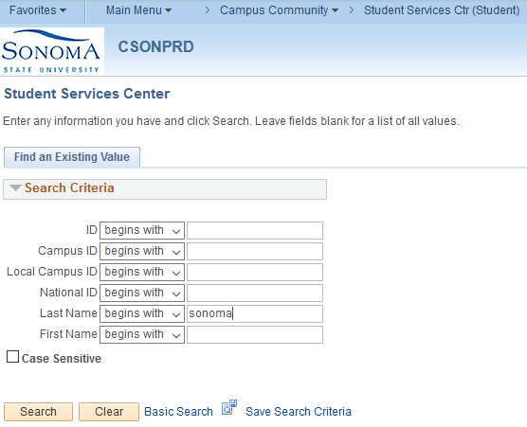

- Under the “Other Academic” dropdown menu, select Academic Requirements.
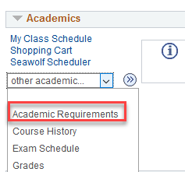

- The top of the report lists the current academic objectives. Majors and Minors are listed as Plans. Concentrations are listed as Subplans. Catalog Year for each item is displayed in the right-hand column.
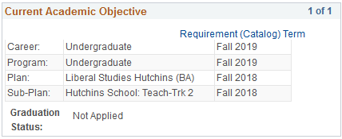
- Also displayed is the Academic Summary information panel. This displays Last Term Registered, Academic Standing, Overall GPA, and Sonoma GPA at the top of the report under Current Academic Summary.
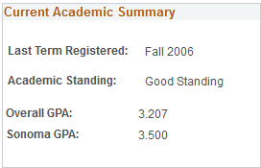

- Degree Audit Icons – The legend on the report explains what each degree audit icon represents.

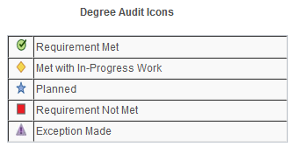

- Course Icons – This legend explains the icons related to coursework.
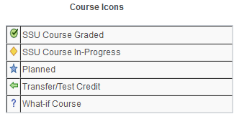

- The default layout of the report automatically minimizes any completed requirements, leaving the incomplete requirements expanded. Use the “Expand all” button to show all requirements.
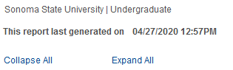
- The blue bars represent new sections of the report, such as GE or Major/Minor requirements.
- The brown text indicates requirements within each section, such as a GE “area.”
- If a requirement is complete, you can click the green arrow to display the course used to complete it.
- Now we see the course used to complete this requirement. Note the green arrow under status, indicating a transfer course was used. Click the description to open course catalog information.
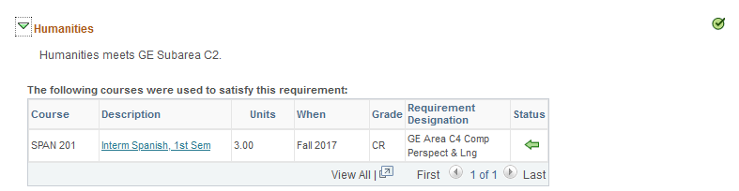

Lesson 2: Transfer Credit Report
Staff can access the same Transfer Credit Report that the student sees in their own Student Center.

- In MySSU navigate to: Campus Community > Student Services Center and search for a student.

- Under the “Other Academics” drop down menu, select Transfer Credit: Report.
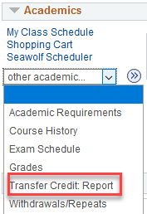

- The report provides a summary of external credit from all schools, tests and other sources.
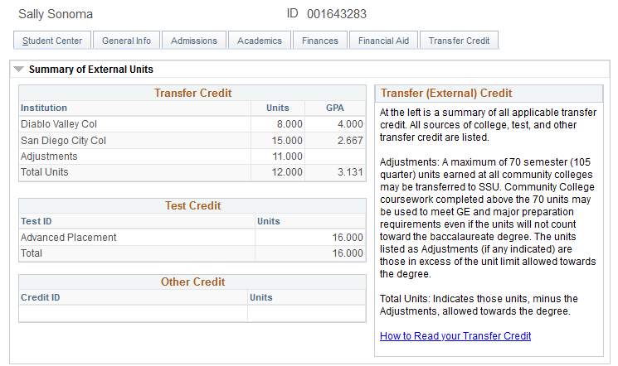
- The legend below describes some of the features of the Transfer Credit Report
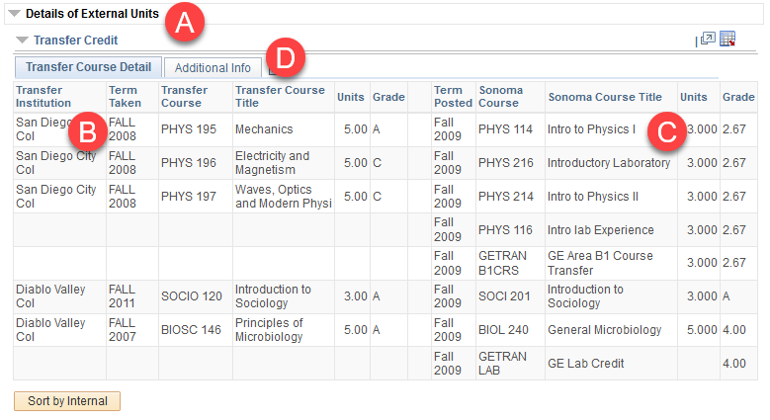
A: Click the arrow next to transfer credit to show your transfer course detail.
B: Transfer Course Detail lists Institution, Term, Course Number, Title, Units and Grade.
C: SSU equivalency information indicates SSU courses the student has been credited with.
D: Use the Additional Info tab to see columns for GE Requirement Designations for SSU courses.

Lesson 3: Course History
Course History includes all courses taken and in-progress work at SSU, as well as all posted Transfer Credit.
- In MySSU navigate to: Campus Community > Student Services Center and search for a student.

- Under the “Other Academic” dropdown menu, select Course History.
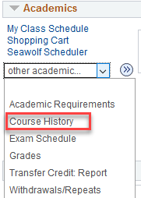
- The same icons that are used on the Academic Requirements Report are used on the Course History page. It uses: Green arrow for transfer course, Green circle for SSU course, Yellow diamond for in progress.

- You can sort the grid of classes by using the Sort Results box at the top.

