Accessing the ARR: Dual Active program/plan stacks

OBJECTIVE:
This lesson shows how to run an ARR for a student that is active in two programs at once, such as UGRD and PBAC.
PEOPLESOFT CATEGORY: Academic Advising
TABLE OF CONTENTS
TITLE 1
OBJECTIVE 1
Lesson 1: Accessing the arr for multiple careers 2

If you have additional questions about the instructions and information in this process guide, please go to the Common Management Systems section of the IT Staff Directory on the Sonoma State website to find a staff resource.
For other guides, visit CMS How-Tos & FAQs.
If you encounter an accessibility problem with this document, please report an accessibility problem on the Sonoma State website.
Please note: to access the hyperlinks in this document, hold down CTRL on your keyboard while you click the link.

Lesson 1: Accessing the ARR for Multiple Careers
Introduction: A student can have two active Program/Plan Stacks at one time, which has caused problems with the DPR in the past. In PeopleSoft 9.0, the new ARR is able to handle this situation. For example, a student can be working on an Undergraduate Business degree in the Spring semester (UGRD program/plan stack), but has already applied and been accepted to the post baccalaureate MBA degree (PBAC program/plan stack).
- In MySSU, run an ARR through the Student Services Center (student) or Advisor Center.
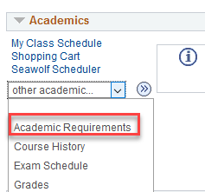

- If a student is active in both a PBAC and a UGRD program. The PBAC ARR will display first.
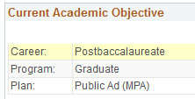
- Once on the ARR, if you see a PBAC program but want to view a UGRD program, scroll down past the General Information box on the report.
- Look for the “Select Institution/Career” box, which will only appear if there is more than one program.

- Select Undergraduate from the dropdown menu and click the “change” button. This will generate the UGRD ARR. Use this menu again if you would like to go back and review the PBAC report.

